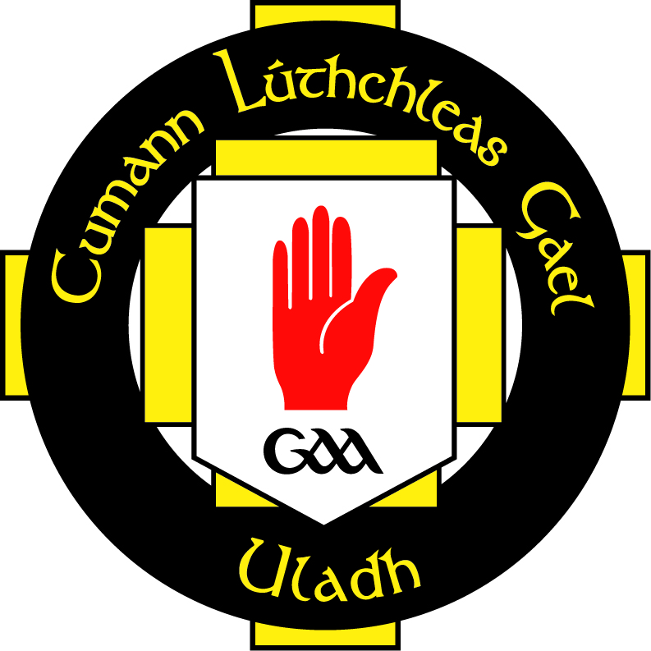

INSERT YOUR CLUB LOGO HERE

Role of Club Cultural Officer / Oifigeach Cultúir

The Cultural Officer of [INSERT CLUB NAME] shall have the remit to:

- Organise Club participation in Scór na nÓg and Scór Sinsear competitions
- Be completely familiar with the Scór rulebook
- Consider organising internal Club Scór talent contests
- Organise an annual Club cultural event; e.g., during ‘Seachtain na Gaeilge’
- Create or promote opportunities for club members and local people to learn Irish and take part in Irish-language activities
- Publicise information about Irish-language scholarships for which club-members may apply
- Ensure that the Club uses the Irish-language version of its name as far as possible, and that Irish terms also appear on other Club materials
- Liaise with the County Cultural Officer
- Liaise with local Irish-language organisations and local council Irish-language officers about learning and promotional initiatives
- Organise social events for older club members
- Organise projects, exhibitions and publications to capture and reflect the history of the Club
- Endeavour to have a cultural component(s) included in all club events, as far as possible
- Consider ways to incorporate Irish or Celtic art into club facilities
- Liaise with other cultural and historical organisations in the local area

[INSERT CULTURAL OFFICER’S NAME] was elected as the Club Cultural Officer on [INSERT DATE]. A six-week probationary period will be completed [INSERT TO AND FROM DATE].

[INSERT CULTURAL OFFICER’S NAME] received training for this role through [INSERT TRAINING TITLE] on [INSERT DATE] in [INSERT VENUE].

Person in role (Cultural Officer):
Signed: ______________________________ Date: _________________________

Club Secretary:
Signed: _______________________________ Date: _________________________

