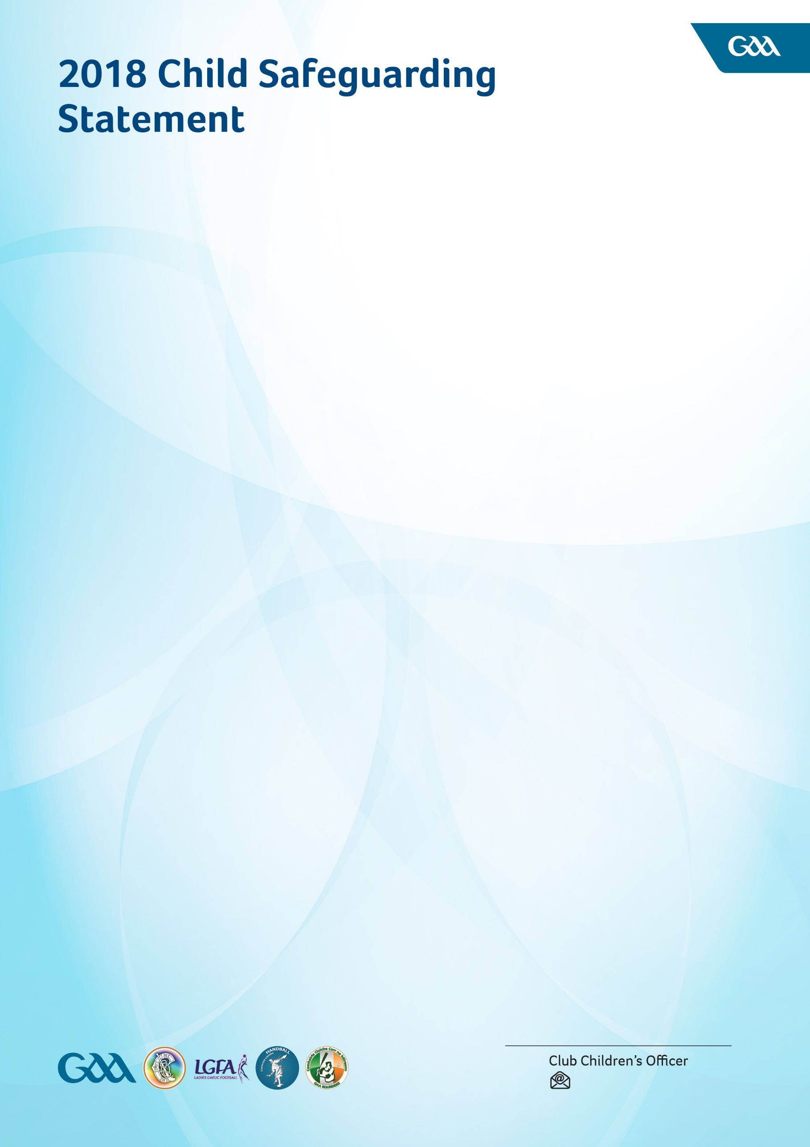

The Gaelic Athletics Associations (GAA, LGFA, Camogie, Rounders, and Handball) in accordance with our Code

of Behaviour (Underage) and our legislative requirements have agreed this Child Safeguarding Statement which is binding on all members and units of our Associations.

The basic aims of the Gaelic Games Associations include fostering and developing our Gaelic Games and Irish cultural activities among young people and children.

These games and related activities are organised and promoted by dedicated volunteers at Club, County, Provincial and National levels with the cooperation and support of an equally dedicated cohort of staff all of whom are committed to the safeguarding of children in our Associations as we seek to create a safe environment for young people in which to grow and develop.

We have completed an assessment of the potential for harm to children when they are participating in our games and attending our activities under the following headings: Club and Coaching Practices; Complaints & Discipline; Reporting Procedures; Use of Facilities; Recruitment; Communications and a further heading of General Risk of Harm.

In addition to our Risk Assessment document described above, the following procedures support our intention

to safeguard children availing of our services:

* Code of Behaviour (Underage) which includes
  + Recruitment policy for those working with children
  + Child safeguarding training requirements
  + Anti-Bullying statement
  + Social Media policy
* Guidance for Dealing and Reporting Allegations or Concerns of Abuse by staff or volunteers
* Appointing Designated Liaison Persons at Club, County and national levels
* Appointing Children’s Officers at Club, County and national levels who shall be the Association’s relevant persons or first point of contact in respect of this statement

The GAA appointed Mandated Person, who has a legal obligation to report harm of children as per legislation is Gearóid Ó Maoilmhichíl. Contact: [mandatedperson@gaa.ie.](mailto:mandatedperson@gaa.ie)

We are committed to the implementation of this Child Safeguarding Statement and the procedures contained therein that outline our intentions to keep children safe from harm.

Our Child Safeguarding Statement has been prepared in accordance with the legislature requirements contained in the Children First Act 2015 and the Children (NI) Order 1995 and as required by our Association rules and will be reviewed in January 2019.

Club's crest here