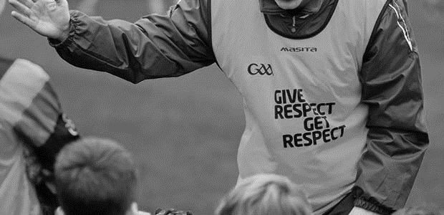
Club Children’s Officer
ROLE DESCRIPTION

INSERT YOUR CLUB LOGO HERE

Role description
The Club Children’s Officer shall assist in promoting a child and youth centred ethos in [Insert Club Name]. In their work the Club Children’s Officer shall be the link between the children/young people and the adults within the Club and shall be the primary protagonist of the Code of Behaviour (Underage) in the Club.
The key role of the Club Children’s Officer is to ensure the implementation and promotion of the relevant Child Welfare and Protection Codes and Guidelines for good practice in their Club so as to ensure that young people can participate, enjoy and benefit from our Gaelic Games in safe and enjoyable surroundings. The Code of Behaviour (Underage) is the agreed good practice reference and policy document that is central to guiding the Children’s Officers in their roles.

Reports / accountable to
[Insert Club Name] Executive Committee

Responsibilities
The main duties of the Club Children’s Officer are summarised as follows:

OVERSEE THE IMPLEMENTATION OF THE CODE OF BEHAVIOUR
- Promote awareness of the joint Code of Behaviour (Underage) within the Club
- Distribute and oversee the implementation of the Code of Behaviour – when working with underage players and ensure in so far as possible, that all Players, Coaches, Team Mentors, Parents, Guardians, Officials and Spectators adhere to the Code
- Deal with breaches of the Code of Behaviour (Underage) as per relevant guidelines

ENSURE VOLUNTEERS MEET APPROPRIATE REQUIREMENTS
- Ensure that all persons, in accordance with their allocated roles, fulfil their vetting, child safeguarding and coach educational requirements as appropriate
- Identify the need and facilitate the delivery of Child Protection in Sport Awareness Workshops and other relevant Child Protection and Welfare training within the Club
- Oversee the implementation of Garda Vetting/Access NI/CRB checks, as appropriate and for relevant personnel, within the Club
- Retain Vetting ID documentation of Club members as part of the vetting process if required

CLUB POLICY AND PROCEDURES
- Influence policy and practice in the Club in order to prioritise the needs of our underage players and make an annual report the Club AGM
- Promote an Anti-Bullying ethos in the Club and deal with instances or allegations of Bullying in a fair, impartial and constructive manner and in collaboration with others as appropriate
- Display the Association’s Anti Bullying Statement and ensure it is adopted at Club level
- Support the implementation of the RESPECT initiative at Club level in co-operation with team personnel, underage members, referees, spectators, parents/ guardians and the Club Executive
- Oversee the carrying out of the annual risk assessment procedure and thereafter putting an agreed Child Safeguarding Statement on display in the Club
- Develop good practice procedures in the recruitment and selection of persons working with young people in the Club
- Make referrals of alleged allegations of abuse to the Club Designated Person

CLUB MEMBERSHIP AND PARTICIPATION
- Ensure that each under age member signs and submits an annual membership form, a parental consent form as required (away trips etc) and that the necessary medical information of an underage player, as deemed relevant, is made known to the Club and/or the team coaches
- Promote greater consultation with under age players and participation by them in Club activities and planning and that young people are afforded the opportunity to express concerns about their sports activities/experiences within the Club
- Encourage the involvement of parents/guardians in organising Club activities
- Monitor, in association with team coaches, any significant trends or developments relating to the participation of young people in Gaelic Games and report accordingly to the Club Executive or Management Committee

UP-TO-DATE REPORTS
- Maintain on-going contact with the County Board Children’s Officer and with other Club Children’s Officers and as required with the National Children’s Officer
- Report regularly to the Club Executive as required

skills required
- Have good communication skills
- Be approachable and open minded

Knowledge
- Be familiar with An Treoraí Oifigiúil
- Have knowledge with and be familiar with our Child Welfare and Protection Codes and Guidelines
- Have an understanding of relevant child welfare/protection legislation
- Good knowledge of the Association

Other requirements
- Have time to do the job.
- Have a genuine interest in the GAA.
- Motivated to set high standards for the Club.
- Motivated to improve the whole Club and Community associated.
- Have undertaken a Garda Vetting/Access NI/CRB check relevant to their jurisdiction
- Have attended the relevant awareness training on child welfare and protection and availed of Children’s Officer training

PERSON IN ROLE (Club Children’s OFFICER)

Signed: ______________________________ Date: _________________________

Club secretary

Signed: _______________________________ Date: ________________________

