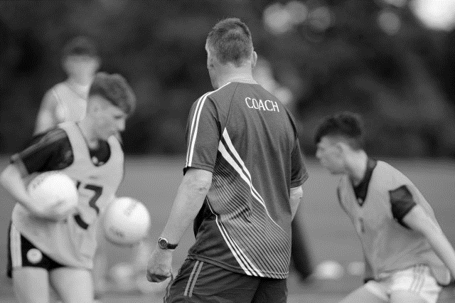
Club Coaching Officer
ROLE DESCRIPTION

INSERT YOUR CLUB LOGO HERE

Role description
The [Insert Club Name] Club Coaching Officer will promote best practice in coaching and games development in the Club, helping to ensure that there is a regular programme of games for all players.

Reports / accountable to
[Insert Club Name] Executive Committee

Responsibilities
The main duties of the Club Coaching Officer are summarised as follows:

CHAIRPERSON OF THE CLUB COACHING AND GAMES COMMITTEE
To act as Chairperson of Club Coaching & Games Committee. The Club Coaching Officer will be responsible for organising periodic meetings of all coaches to review and evaluate progress within the club. A function of this committee should be to promote underage activities in the local community and on player and mentor recruitment.

CLUB SCHOOL LINK
The Club Coaching Officer will forge close links with the local primary schools ensuring the club provides sufficient support through the provision of coaching and games to the pupils. Where appropriate develop a relationship with local post primary schools

COACH EDUCATION
To promote the education and qualification of all coaches within the club. The Club Coaching Officer will encourage all club coaches to attend appropriate courses, workshops and seminars and receive coaching qualifications. The Club Coaching Officer will oversee the recruitment, appointment and development of coaches within the club, e.g. by sourcing mentors.

CLUB COACHING PLAN
- The Club Coaching Officer will lead out in the development and implementation of a Club Coaching Plan.
- Identify key milestones, targets and who is responsible for delivery
- Monitor and evaluate at regular coaching committee meetings – records of targets, goals, players and coaches

skills required
- Good communication and interpersonal skills
- Good organisational skills
- Ability to ensure decisions are taken and followed up
- Ability to delegate key tasks to other officers where required

Knowledge
- Be familiar with An Treoraí Oifigiúil
- Good knowledge of the Association
- Have experience of best practice in Coaching & Games Development

Other requirements
- Have time to do the job.
- Have a genuine interest in the GAA.
- Motivated to set high standards for the Club.
- Motivated to improve the whole Club and Community associated.

PERSON IN ROLE (Club COACHING OFFICER)

Signed: ______________________________ Date: _________________________

Club secretary

Signed: _______________________________ Date: ________________________

