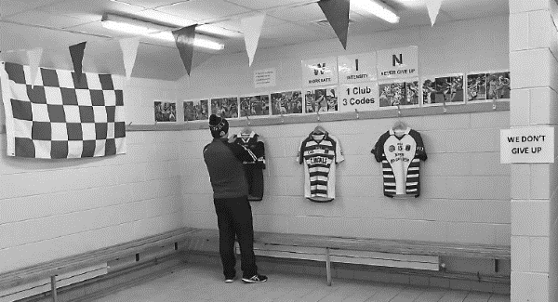
Club Gambling Policy

INSERT YOUR CLUB LOGO HERE

policy statement
[Insert Club Name] Club has developed this Gambling Policy to:
- support the health and wellbeing of its members;
- to protect the integrity of our games and our players;
- provide a positive example in breaking the growing societal link between sport and betting.
In developing the policy, the club executive has considered:
- Our duty of care towards our members, particularly our players and juvenile members who, research shows, are at a higher risk of harmful gambling
- Local community and wider societal concerns regarding harmful or problem gambling
- GAA rules and regulations
- Relevant national law

policy commitments
[Insert Club Name] will ensure that:
- No betting-related sponsorship is accepted for club teams, gear, property, or equipment.
- All officers, players, mentors, and members are aware that GAA Rule 1.15 prohibits players, team management or match officials from betting on games in which they are involved; and that they are aware of the consequences of violating this rule (minimum sanction members face for offence is an eight-week suspension. Expulsion from the Association may also be considered in some cases.)
- The club upholds GAA Rule 5.8: Bookmaking shall not be permitted within Association property. (A member breaching or aiding the breach of this rule will be suspended for 24 weeks.)
- Club communication channels (such as websites, social media platforms, and informal club WhatsApp groups) are not used to promote or discuss betting odds or to carry any related advertising, and that appropriate steps are taken should this directive be violated.
- The Club Lotto is managed in a responsible manner, is adherent to the law, and is not open to juvenile members.
- The GAA’s Gambling Awareness resources are made available to all players and members through our communication platforms.
- Gambling awareness educational opportunities, such as the GAA’s own gambling awareness presentation ‘Reduce the Odds’ or that offered by a reputable external entity, is made available in an age-appropriate manner to playing members.
- This policy is reviewed by the Club Executive every two years or in the aftermath of any official GAA rule change or directive that impacts on it.

declaration
This document has been approved by the Club Executive Committee and serves as the working Club Gambling Policy of [Insert Club Name].

Club Chairperson

Signed: ______________________________ Date: _________________________

Club Secretary

Signed: _______________________________ Date: ________________________

