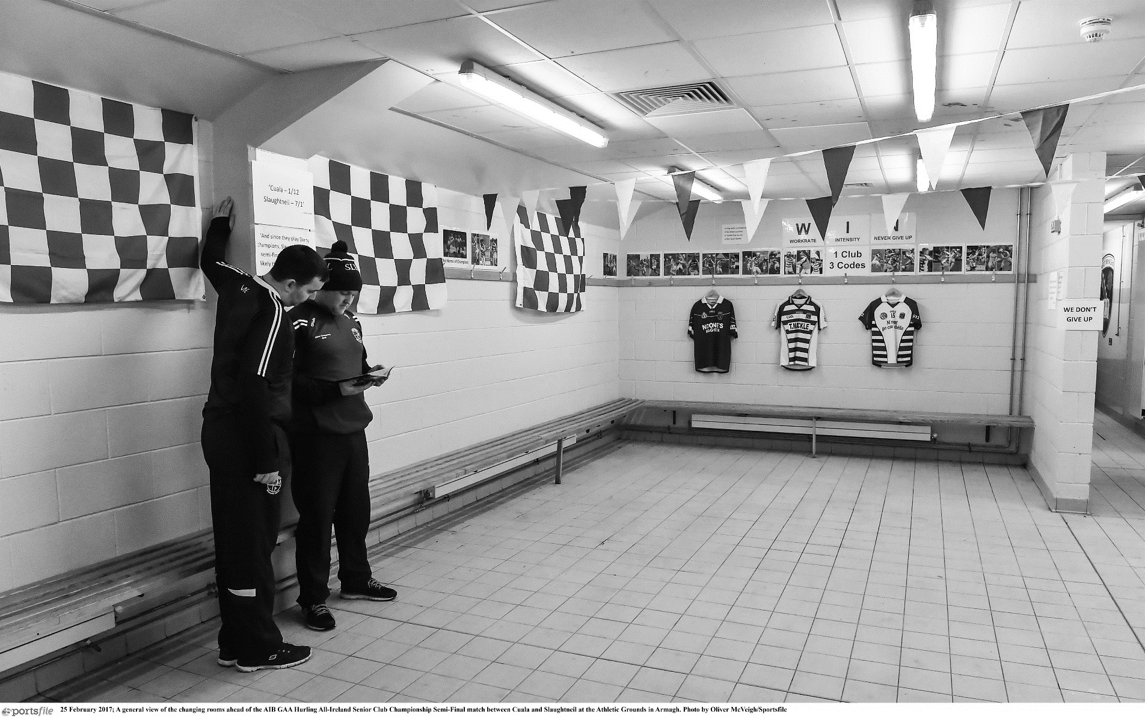
Equality Policy

INSERT YOUR CLUB LOGO HERE

policy statement
- The Club recognises the importance of affording equity, equal opportunity and fair treatment to all present and potential members.
- The Club aims to ensure that all people irrespective of their age, gender, ability, disability, race, religion, ethnic, origin, creed, colour, nationality, social status or sexual orientation have a genuine and equal opportunity to participate in Gaelic Games at all levels and in all roles. That is, as a beginner, participant or performer, and as a coach. Official, referee, manager, administrator or spectator.
- It is the aim of the club in its relationships with its members, employees, job applicants and in the provision of its services, not to disadvantage any individual by imposing any conditions or requirements which cannot be justified. Failure to comply may result in disciplinary action being taken.
- Direct discrimination is defined as treating a person less favourably than others are or would be treated in the same or similar circumstances.
- Indirect discrimination occurs when a requirement or condition is applied which whether intentional or not, adversely affects a considerably larger proportion of people of one race, sex, marital status than another an cannot be justified on grounds other than race, sex or marital status.

objectives
The clubs Equality policy has the following objectives:
- To adopt a planned approach to eliminating perceived barriers which discriminate against particular groups. This will include widening the traditional approach and include communities experiencing disadvantage, poverty and health inequalities.
- To ensure that no-one working or wishing to work for or on behalf of the club receives less favourable treatment on the ground outlined in the Policy Statement above.
- To give clear guidance to individuals working within the club, either employed or as volunteers, on the commitment to equal opportunities.
- To ensure that all those who participate in Gaelic Games, at all levels and in roles receive fair and equitable treatment.
- To ensure that the format and content of all competitions, regulations and assessments provide equality for all, except where specific situations and conditions properly of reasonably prevent this.
- To ensure that all materials prepared, produced and distributed by or on behalf of the club promote a clear image of the profile of all those who involved in the games.

Responsibly
The Club expects all those acting on behalf of the association to adhere to this policy. In pursuance of this policy the Club Executive Committee reserve the right to discipline any of its members or employees who practice any form of discrimination on the grounds of a person’s age, gender, ability, race, religion ethic origin, creed, nationality, social status or sexual orientation.

declaration
This document has been approved by the Club Executive Committee and serves as the working equal opportunities document of [Insert Club Name].

Club Chairperson

Signed: ______________________________ Date: _________________________

Club Secretary

Signed: _______________________________ Date: ________________________

