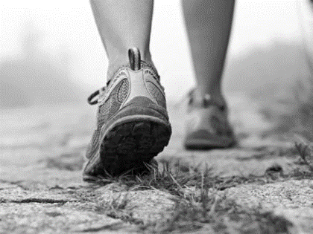
Healthy Club Officer
ROLE DESCRIPTION

INSERT YOUR CLUB LOGO HERE

Role description
The role of the Healthy Club Officer is to help ensure that [Insert Club Name] is a healthier place for everyone to enjoy. The Healthy Club Officer will be supported in this work by the Club Executive and the County Health & Wellbeing Committee.

Reports / accountable to
[Insert Club Name] Executive Committee

Responsibilities
The main duties of the Healthy Club Officer are summarised as follows:

LIAISE WITH THE COUNTY HEALTH & WELLBEING SUB-COMMITTEE AND CLUB EXECUTIVE
- Ensure the club is appropriately represented at training or other events organised through the County Health & Wellbeing Sub-Committee.
- Promote and support at club level any activities organised by the County Health & Wellbeing Sub-Committee committee.
- Provide reports, as required, to the Club Executive on plans and activities, including a report for the club AGM on work completed and any plans for the subsequent year.

ENSURE APPROPRIATE POLICIES AND ACTIVITIES ARE IMPLEMENTED AT CLUB LEVEL
- Using the resources available ensure that policies such as the Club Drug & Alcohol policy template and the Club Mental Health Charter, are implemented.
- Ensure that the club has a Critical Incident Response Plan in place
- Promoting health activities and partnerships developed at national, provincial, and county level that may benefit club members.
- Where appropriate or necessary, work with local service providers/agencies/charities who are seeking to make their services available to club members.
- Work with the club Executive to promote health messages at club games and events.
- Encourage the club to include the wider community (parents, past players, older men etc) in any health promoting plans or activities.

skills required
- Have good communication skills
- Be approachable and open minded
- Good standing in the community
- Ability to deal discretely with potentially sensitive issues

Knowledge
- Be familiar with An Treoraí Oifigiúil
- Good knowledge of the Association
- Interest in health and wellbeing

Other requirements
- Have time to do the job.
- Have a genuine interest in the GAA.
- Motivated to set high standards for the Club.
- Motivated to improve the whole Club and Community associated.
- Attend Healthy Club Officer training as provided by County Health & Wellbeing Committee
- Willingness to attend training as provided by the GAA or its partners

PERSON IN ROLE (healthy club OFFICER)

Signed: ______________________________ Date: _________________________

Club secretary

Signed: _______________________________ Date: ________________________

