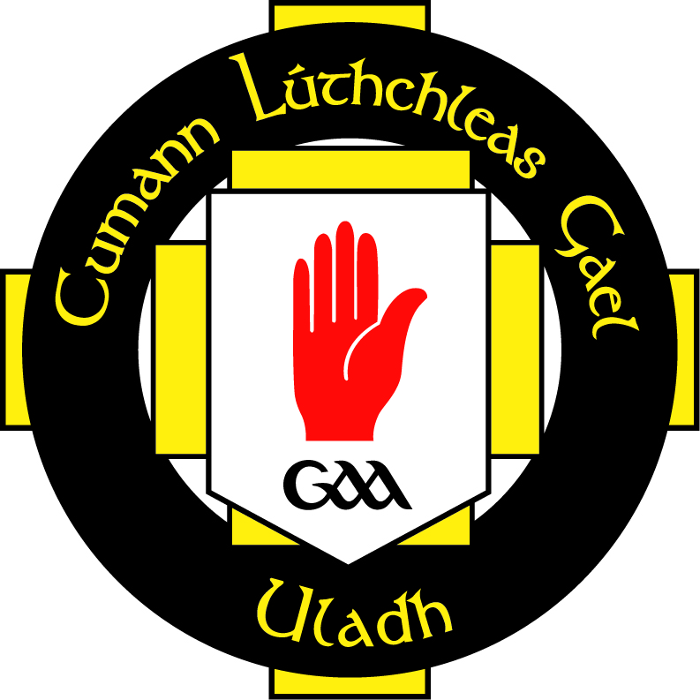

Ulster GAA Equal Opportunities Policy

INTRODUCTION

1. Ulster GAA is committed to the promotion of equality of opportunity. We are opposed to all forms of unlawful and unfair discrimination, both direct and indirect, in terms of both employment and the provision of goods, facilities and services. The aim of this policy is to help all staff and volunteers develop their full potential, to ensure that the talents and resources of the staff and volunteer base are fully utilised, and that users/providers of goods, facilities and services attaching to Ulster GAA are treated fairly.

2. Ulster GAA will treat all staff and volunteers equally, irrespective of:

- gender, gender re-assignment, marital or family status
- religious belief or political opinion
- disability
- race or ethnic origin
- nationality
- sexual orientation
- age
- dependency / caring status

3. We are opposed to all forms of unlawful and unfair discrimination. All job applicants, employees and others who work for us, along with those who use or provide goods, facilities or services attaching to Ulster GAA will be treated fairly and will not be discriminated against on any of the above grounds. Decisions about recruitment and selection, promotion, training or any other benefit will be made objectively and without unlawful discrimination.

We recognise that the provision of equal opportunities is not only good management practice, it also makes sound business sense. Our equal opportunities policy will help all those who work for us to develop their full potential and the talents and resources of the workforce will be utilised fully to maximise the efficiency of the organisation.

COMMITMENT

4. We are committed to:

• Promoting equality of opportunity for all persons
• Promoting a good and harmonious working environment in which all persons are treated with respect
• Preventing occurrences of unlawful direct discrimination, indirect discrimination, harassment and victimisation
• Fulfilling all our legal obligations under the equality legislation and associated codes of practice
• Complying with our own equal opportunities policy and associated policies
• Taking lawful affirmative or positive action, where appropriate
• Regarding all breaches of equal opportunities policy as misconduct which could lead to disciplinary proceedings.

This policy is fully supported by senior management and has been agreed with our executive board.

IMPLEMENTATION

5. The Secretary of Comhairle Uladh has specific responsibility for the effective implementation of this policy. All managers and supervisors also have responsibility for implementing aspects of the policy. The organisation expects all staff and volunteers to abide by the policy and help create the equality of opportunity environment that the policy seeks to establish.

6. This policy will be communicated to all staff and volunteers.

7. Appropriate training will be provided for staff and volunteers on equality and diversity when appropriate.

MONITORING AND REVIEW

8. The provision of equality of opportunity will be monitored by the collection of information on staff and volunteers. This will include, as a minimum, information on age, ethnic background, gender and status as a disabled person. The organisation may also decide to collect additional information such as community background, marital and family status, but will not seek information on the sexual orientation of volunteers.

9. Progress on the implementation of this policy and the equal opportunities programme will be reviewed annually in consultation.

COMPLAINTS

10. Employees and Volunteers who believe they have been subject to any form of discrimination, harassment or victimisation are entitled to raise the matter through the agreed procedures. All complaints of discrimination will be dealt with seriously, promptly and in complete confidence.

11. In addition to our internal procedures, employees have the right to pursue complaints of discrimination to an industrial tribunal or the Fair Employment Tribunal under the following anti-discrimination legislation:

• Sex Discrimination (Northern Ireland) Order 1976, as amended
• Disability Discrimination Act 1995, as amended
• Race Relations (Northern Ireland) Order 1997, as amended
• Employment Equality (Sexual Orientation) Regulations (Northern Ireland) 2003
• Fair Employment and Treatment (Northern Ireland) Order 1998, as amended
• Employment Equality (Age) Regulations (Northern Ireland) 2006
• Equal Pay Act (Northern Ireland) 1970, as amended.

12. The organisation will make every effort to ensure that staff or volunteers making complaints will not be victimised. Any complaint of victimisation will also be dealt with seriously, promptly and in complete confidence and may result in disciplinary action against the offender which may lead to suspension or dismissal.

Date: 27/02/2014

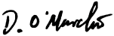
Signature:

