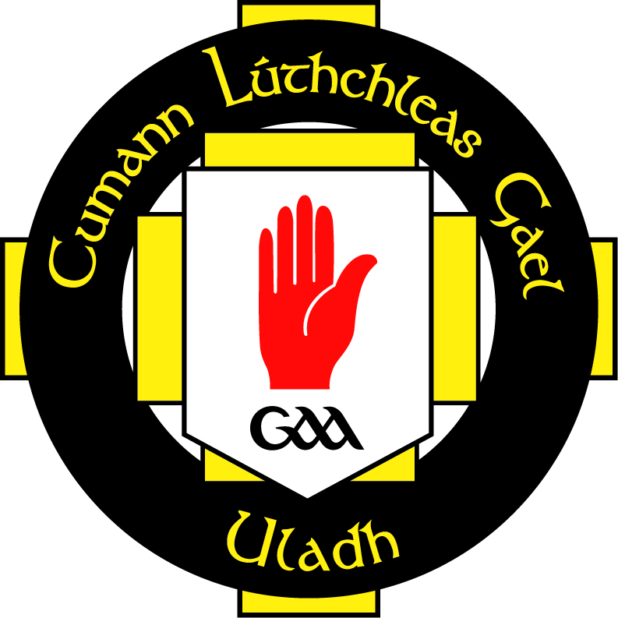
Cumann Lúthchleas Gael

Comhairle Uladh
Ulster Club Football League
c/o Stephen Donnelly
8-10 Sraid an Mhargaidh
Ard Mhacha
Co Ard Mhacha
Ulster Club Football League
2016 Application Form
IARRTAS (Application) – to be completed by club
Club ……………………….………………………………… Colours: ………………………………………………...........

Contae ……………………………………..…………........ Division (2016): ................................................................
We, the undersigned, wish to make application to Comhairle Uladh, to enter the 2016 Ulster Club Football League. We enclose herewith a non-refundable cheque for €200 / £175 (made payable to Comhairle Uladh).

Contact Info:

Sínithe …………………………………………...………… Cathaoirleach

……………………………………………...……... Rúnaí ……………….…………….... Dáta

It is proposed to run the group stages on a regional basis, depending on the number of applications received, with the competition commencing on Sunday 31st January 2016.

Application forms with appropriate fee must be returned to Comhairle Uladh before 1.00pm on
Friday 8th January 2016.

B
CEAD AN CHOISTE CHONTAE (County Committee Permission)
The above application has been approved by Coiste Cho. ………………………………………………………………..
and I herewith enclose cheque for €200 / £175 Registration Fee.

Sínithe …………………………………………...………… Rúnaí Chontae

……………………………………………...……... Dáta
C
CEAD AGUS DAINGNIÚ (Permission and Ratification)
The above application has been approved by Comhairle Uladh and receipt of Registration fee is hereby acknowledged.

Sínithe …………………………………………...………… Rúnaí Coiste

……………………………………………...……... Dáta
Club Secretary: ……………………….……………………
Address:……………………….……………………
……………………….……………………
……………………….……………………
Phone No:……………………….……………………
Active E-Mail: ……………………….……………………
Club Chairman: ……………………….……………………
Address:……………………….……………………
……………………….……………………
……………………….……………………
Phone No:……………………….……………………
Active E-Mail: ……………………….……………………

A

