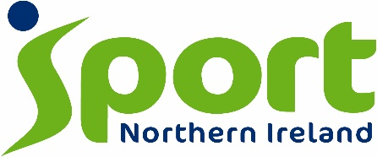
‘Defibrillators for Sport’ Programme

The Department for Communities and Sport NI recently launched an initiative to provide life-saving defibrillators to sports clubs. The intended purpose is to increase the number of Automated External Defibrillator (AED) devices available in community settings. This initiative supports the Department of Health’s Community Resuscitation Strategy and therefore strengthens the 'Chain of Survival' link in both rural and urban areas.

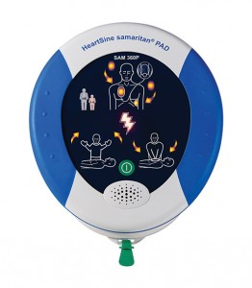
The HeartSine Technologies Samaritan 360p defibrillator device

Almost 899 AED devices have already been distributed amongst sports clubs across Northern Ireland. 195 devices will be distributed in phase 3 bringing the total across all 11 councils to 1094, it is envisaged that Public Access Defibrillation will increase, supporting the Community Resuscitation Strategy whilst widening and strengthening the ‘chain of survival’.

Who Can Apply

Sports clubs are welcome to apply. Even if your club / organisation already possesses a defibrillator, you may be eligible to receive a new AED through this initiative.

Clubs already possessing a defibrillator

The Community Resuscitation Strategy has identified the need to increase provision of AEDs in community settings and this survey will gauge the requirement from a sporting perspective. If your club already has an AED, devices obtained prior to 2007 should be considered obsolete and measures should be taken to replace such equipment. Accordingly, clubs with older devices will be eligible to apply for a new AED.

Key Dates and info

The application link is currently OPEN and interested parties can apply until 12:00 noon 4th September 2017

To apply for a defibrillator, please click on the application link above. The application process should take less than 5 minutes to complete.

First come, first served – where there is an oversubscription in registering for devices in a particular LGD / District Council area, a ranking order will be generated using the date and time that survey responses were received.

Additional Information
- Successful applicants will be asked to provide Sport NI with the details of where the AED will be located in order to inform the NI Ambulance Service.
- Once released, the subsequent storage, maintenance and upkeep of the devices will become the responsibility of recipients.
- Training will be offered at a later date.

Guidance Notes

For further information on Defibrillators for Sport please contact:
- Conleth Donnelly on 02890 383233
- Chris Craig on 02890 383859

