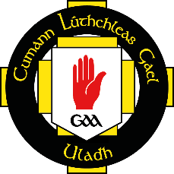
Cumann Lúthchleas Gael
Comhairle Uladh

2018 FinTrU Ulster GAA Football Inter-Firms
Player Registration

Ainm | Name | Club | Contae

This must be completed and returned by Friday 27 October 2018 to niall.muldoon.ulster@gaa.ie

