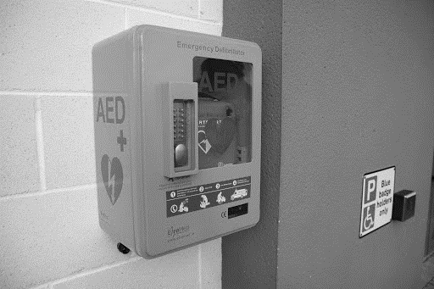

INSERT YOUR CLUB LOGO HERE

AED Protocol

INTRODUCTION
[Insert Club Name] have a defibrillator located on our grounds at: [Insert Location Details]. This will be promoted widely through our club and to the wider community.

Where will the aed be placed?
The AED located at [Insert Location Details] is easily accessible. To avoid difficulties accessing an AED in the event of an emergency, it is advised that the AED should not be kept under lock and key. However, if kept in an area which is locked, keys must be convenient to hand. [AMEND AS APPROPRIATE]

who will provide the initial aed training?
The following people have received training in AED use: [extend as necessary]
Name | Date of Training / Refresher Training | Contact Details
This training has been provided by an accredited first aid organisation/person [INSERT DETAILS]. The contents of the course are in accordance with the training recommendations set out for Cardiopulmonary Resuscitation and Automated External Defibrillation.
The above list of trained personnel is displayed beside the AED.

ongoing training commitment
All trained personnel will update their training at least once a year but preferably every 6 months to ensure best practice.

who will be responsible for checking the aed
[Insert Name (Contact Details)] is the Designated Person(s) to look after the maintenance of the club AED. This is carried-out in accordance with the manufacturer’s recommendations, taking into account the following:
- AED
- Pad’s expiry date
- Battery – to ensure it is working
- Face mask – present
- Scissors - present
- Razor – present
- Towel/dry cloth – present
Should any issues arise the Designated Person(s) will report this immediately to the Club Chairperson and corrective action taken immediately. This will be logged in the AED maintenance log-book. If the AED is unusable for any length of time this will be communicated on the Club’s website and sent to relevant community contacts if it is the only AED in the locality.

have you notified the insurance company of your organisation to let them know there is an aed on site?
Our club have informed our insurance broker of the fact that an AED is located at the club. This will provide cover in the event of the equipment being stolen or damaged.

is there aftercare/debriefing available for the person/s who have used the aed in a cardiac arrest situation?
Our Club commit to following-up with any responder(s) after having to use an AEDA to ensure they are ok, and to ascertain if they wish to remain as one of our designated responders.
Our Club acknowledge that Defibrillation is the third link in the chain of survival. Trained personnel prior to link 3 should be able to:
Link 1 – Recognise signs and symptoms and call 999/112 for help
Link 2 - Carry out CPR in a collapsed, non-breathing casualty.
Link 3 – Early Defibrillation
Link 4 – Post Resuscitation Care. Ambulance personnel arrive.

declaration
This document has been approved by the Club Executive Committee and serves as the working Club AED Protocol of [Insert Club Name].

Club Chairperson

Signed: ______________________________ Date: _________________________

designated person

Signed: _______________________________ Date: ________________________

