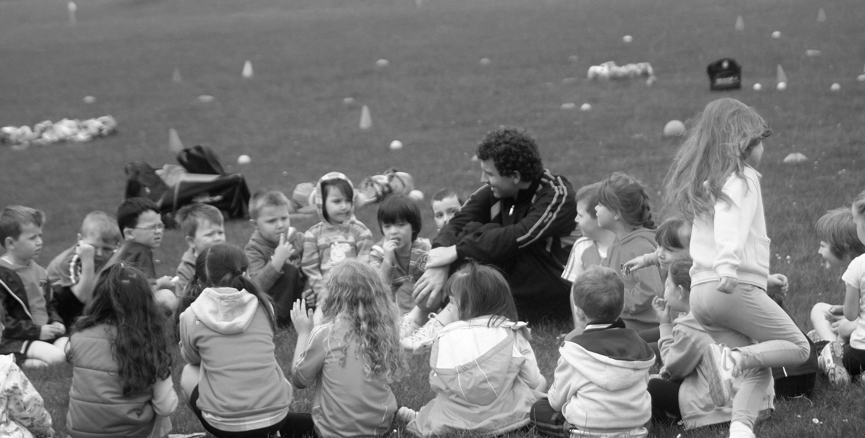
Club Designated Liaison Person (DLP)
ROLE DESCRIPTION

INSERT YOUR CLUB LOGO HERE

Role description
All Clubs are obliged on an annual basis to appoint Designated Liaison Person, known as the DLP, who on behalf of the Clubs shall be responsible at an initial stage for dealing with any concerns relating to the possible abuse of children as reported or made known to them.
The role of the DLP should not be confused with that of the Club Children’s Officer. They are in essence two distinct roles with the Children’s Officer dealing primarily with the Code of Behaviour (Underage), with vetting, safeguarding training of coaching personnel and others while the DLP is charged with assisting in the collation of information and the reporting of allegations and concerns of abuse in the Club.
NI
- Have knowledge & be committed to Code of Behaviour (Underage), Guidance for Dealing with & Reporting Allegations & Concerns of Abuse and Children First (ROI) /NI Legislation
- Have a knowledge of categories and indicators of abuse
- Undertake training in relation to child protection (Safeguarding 1 and 3)
- Beware of local contacts and services in relation to child protection i.e. principal and duty social workers and their contacts
- Communicate with parents and/or Statutory Agencies as appropriate
- Follow reporting procedures and inform Gateway Team (NI) of any concerns or allegations
- Inform National DLP of any concerns or reports made. Advice is available from the National DLP
- Be easily contactable
- To inform Gateway Team and or PSNI of relevant concerns about individual children, using the Standard Reporting Form. Keep a copy of this form and ensure acknowledgement of receipt of this form
- Report persistent poor practice and breaches of the Code to the National Designated Liaison Person
- Advise club administrators on issues of confidentiality, record keeping and data protection
Note: The DLP cannot deal with an allegation against an adult in the club as well as deal with the allegation of the child in the club who has been allegedly abused by the adult.

ROI
- Have knowledge & be committed to Code of Behaviour (Underage), Guidance for Dealing with & Reporting Allegations & Concerns of Abuse and Children First (ROI)
- Have a knowledge of categories and indicators of abuse
- Undertake training in relation to child protection (Safeguarding 1 and 3)
- Beware of local contacts and services in relation to child protection i.e. principal and duty social workers and their contacts
- Communicate with parents and/or Statutory Agencies as appropriate
- Follow reporting procedures and inform Statutory Agencies of any concerns or allegations
- Inform National DLP of any concerns or reports made. Advice is available from the National DLP
- Be easily contactable
- To inform TUSLA and/or An Garda Síochána of relevant concerns about individual children, using the Standard Reporting Form. Keep a copy of this form and ensure acknowledgement of receipt of this form
- Report persistent poor practice and breaches of the Code to the National Designated Liaison Person
- Advise club administrators on issues of confidentiality, record keeping and data protection

Note: The DLP cannot deal with an allegation against an adult in the club as well as deal with the allegation of the child in the club who has been allegedly abused by the adult.

who is the dlp in the club?
- The Club Chairperson automatically assumes the role of DLP unless another person is chosen and ratified by the relevant Club Executive Committee or County Committee to undertake the role.
- The role of DLP is not an Officership role at Club Executive level but is a key role in ensuring we adhere to our legal responsibilities in the safeguarding of children in our Clubs.

what should a dlp do when they receive an allegation or concern of abuse in roi?
- Note dates, times, locations, context.
- Any other relevant information.
- Consult informally with TUSLA if unsure.
- Report to TUSLA or Gardaí.
- Using official reporting form from TUSLA.
- Report to your Association’s Mandated Person / DLP.
- Seek advice from the Statutory Authorities or National DLP regarding informing the family.
- Should a DLP or the Association’s Mandated Person, having appraised a concern, decide for whatever reason not to report the concern to the relevant statutory authority they must record their reason for not reporting. The volunteer or employee who raised the concern should be given a written explanation for not reporting and should be advised that they may report themselves.

what should a dlp do when they receive an allegation or concern of abuse in ni?
- Note dates, times, locations, context.
- Any other relevant information.
- Consult informally with Gateway if unsure.
- Report to Gateway Team and / or PSNI.
- Using official reporting form from Gateway.
- Report to your Association’s Mandated Person / DLP.
- Seek advice from the Statutory Authorities or National DLP regarding informing the family.
- Should a DLP or the Association’s Mandated Person, having appraised a concern, decide for whatever reason not to report the concern to the relevant statutory authority they must record their reason for not reporting. The volunteer or employee who raised the concern should be given a written explanation for not reporting and should be advised that they may report themselves.

PERSON IN ROLE (Club Designated Liaison Person)

Signed: ______________________________ Date: _________________________

Club secretary

Signed: _______________________________ Date: ________________________

