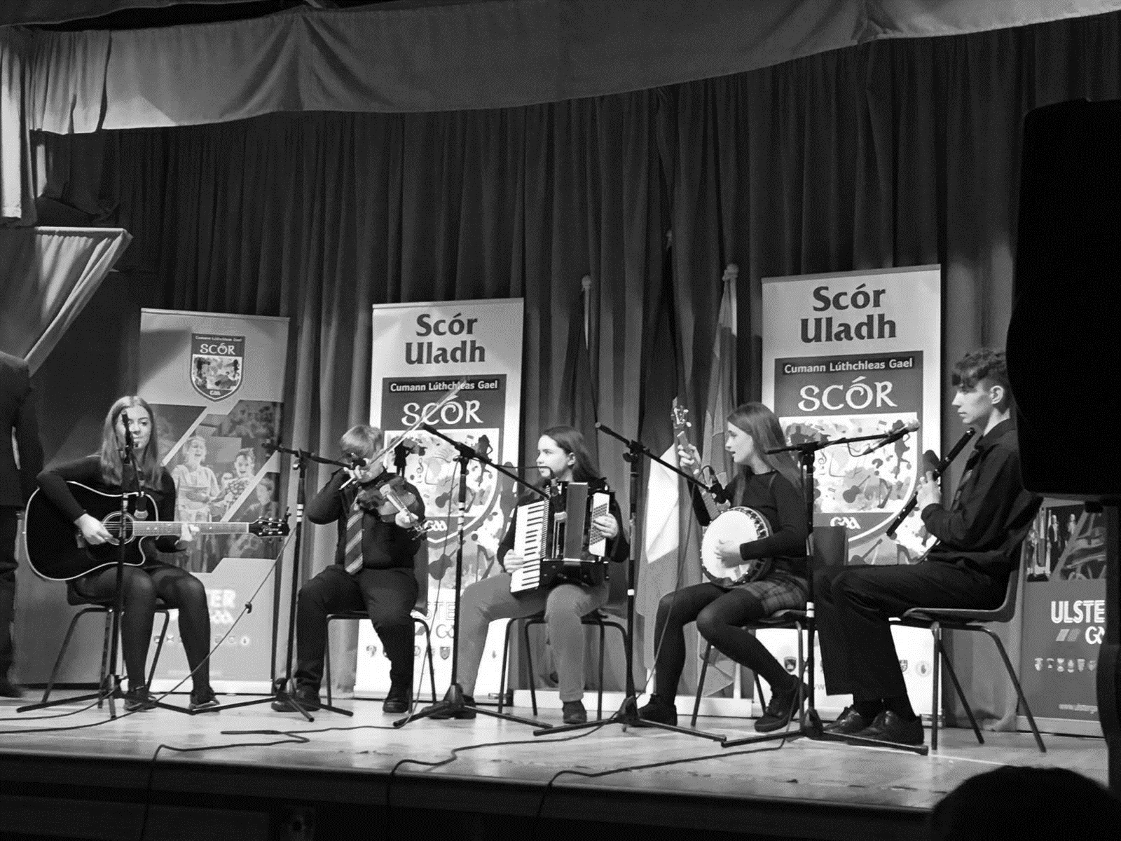
Club Irish Language and Cultural Officer
ROLE DESCRIPTION

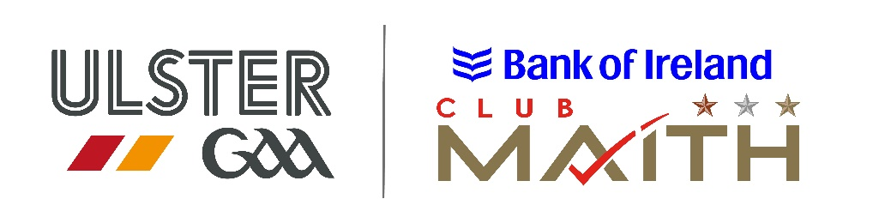

INSERT YOUR CLUB LOGO HERE

Role description
The role of the Club Irish Language and Cultural Officer is to provide advice to the Club’s officers in supporting the National Language and Culture as well as actively promoting the Irish language within [Insert Club Name].

Reports / accountable to
[Insert Club Name] Executive Committee

Responsibilities
- Act as Cathaoirleach of the Coiste Cultúir agus Teanga sa Chlub (Club Culture and Language sub-committee) and to be a member of the Club Executive.
- Provide a service / input for Club Publications / Programmes and Medals and Trophies.
- Liaise with other language and cultural groups within the county.
- Liaise with Clubs regarding Cúrsaí Gaeilge.
- Act as Club Scór co-ordinator in liaison with Scór Secretary.
- Encourage the use of bi-lingual materials (signs etc.) within the Club.
- Register with Fondúireacht Sheosaimh Mhic Dhonncha.
- Provide social media posts as Gaeilge for the Club’s social media platforms.
- Administer County Gaeltacht Scholarships Schemes.

Skills required
- Have a good written and spoken knowledge of the Irish Language (Gaeilge).
- Have good communication skills.
- Ability to delegate tasks.
- Have good organisational skills.
- Be IT literate.

Knowledge
- Eolas maith ar an teanga dhúchais agus ar chultúr traidisúnta an chontae.

Other requirements
- Have time to do the job.
- Have a genuine interest in the Association.
- Have a genuine interest in the Irish language and culture.
- Be of good standing in the community.

PERSON IN ROLE (Club cULTURE AND LANGUAGE OFFICER)

Signed: ______________________________ Date: _________________________

Club secretary

Signed: _______________________________ Date: ________________________

