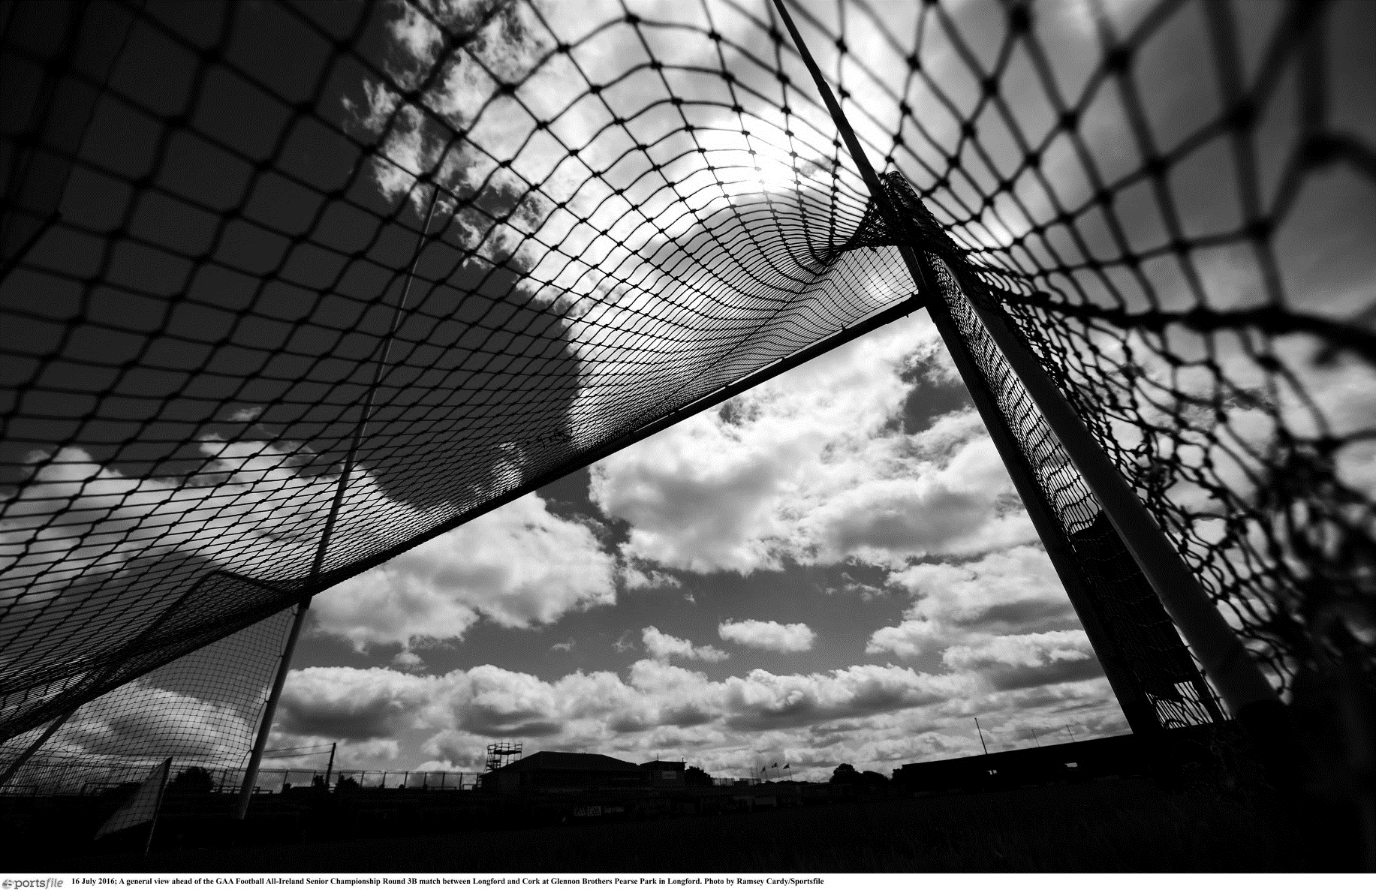
Data Protection Policy

INSERT YOUR CLUB LOGO HERE

CLUB dATABASE GUIDELINES
[Insert Club Name] complies with the requirements of the Data Protection Act 2018 with regard to the collection, storage, processing and disclosure of personal information and it is committed to upholding the Act’s core Data Protection Principals. The Club is also compliant with GDPR guidelines.
Details of Club Data Protection Information are provided on the back of the Club Registration Form and the Club Data Controller [Insert Name of Club Data Controller] can be contacted via e-mail [Insert email], the GAA Data Protection Officer can be contacted via e-mail: dataprotection@gaa.ie.
The club strives to ensure that it keeps a comprehensive data of all its members either on computer or otherwise. The club should ensure that is stores information on the following groups within the club:

PLAYING / NON-PLAYING MEMBERS
The information that should be stored on all non-playing members is as follows:
- Names
- Address
- DOB
- Occupation
- Home Tel Number
- Work Tel Number
- Mobile Number
- Special Medical Conditions
- Parents’/Guardians’ contact details (for underage)

CLUB OFFICIALS
Information is stored on all club officials, both Executive Committee and all sub-committee members. The information stored is followed:
- Name
- Address
- DOB
- Occupation
- Role within club
- Home Tel Number
- Work Tel Number
- Mobile Number
- Special Medical Conditions
- Administration Courses Attended

CLUB COACHES
The information that should be stored on club coaches/volunteers is as follows:
- Name
- Address
- DOB
- Occupation
- Home Tel Number
- Work Tel Number
- Mobile Number
- Special Medical Conditions
- Actively Coaching?
- Team Coached
- Coaching Qualifications and Dates Achieved.
- Ulster Council and CPD Qualifications
- Child Protection Qualifications
- First Aid Qualifications
- Other relevant qualifications (and dates)

photography and filming
It should be noted that having photographic and filming guidelines is not about preventing parents and guardians from taking pictures, but rather to ensure that only those who have a right to take photographs do so and that all images are captured in a sensible and non-intrusive way.
These safeguards should still permit and facilitate the recording of relevant and suitable materials, should allow us to photograph the enjoyment gained by participating in our games, should enable coaches to use the latest technology in the delivery of training skills and should also enable [Insert Club Name] to promote their activities in a safe and non-threatening manner.
A common sense approach is required when deciding on what may or may not be appropriate as we do not wish to prohibit the recording of games, coaching or celebrations at club level through the use of photography or by recording on video equipment
The key issues that we should address regarding the use of images and photographs of children/young people are:
- Ensuring agreement and permission of parents/ guardians in the taking and any use of images/ photographs
- Seeking such agreement as part of the annual membership affiliation process or by use of parental consent forms
- Avoiding the individual identification of children in group or team photographs unless by agreement e.g. For special events, an award or achievements ceremony
- Ensuring prior accreditation is given to ‘professional photographers’ who may attend your games or events
- Ensuring that images/photographs chosen are suitable and in good taste with the images chosen or recorded focussing on activity rather than a particular child
- Clubs, coaches and volunteers permitting the use of video equipment as a legitimate coaching aid and as a means of recording special occasions; however, care should be taken in the dissemination, storage and use of such material
- Parents and spectators taking photographs/recordings should where possible seek permission in advance from the Club/County Board and should also be prepared to identify themselves if requested and state the purpose for their photography/filming. If Club/County Board personnel are unhappy about any matter relating to such photography the permission granted may be withdrawn immediately
It should be noted that we have little or no influence on what photographs may be taken and published in local or national newspapers as such photography is covered by a different set of guidelines. Should we ever be unhappy with the publication of such photographs or images we can address this matter with the individual newspaper or the Press Council of Ireland and the Office of the Press Ombudsman.

declaration
This document has been approved by the Club Executive Committee and serves as the working Data Protection Policy of [Insert Club Name].

Club Chairperson

Signed: ______________________________ Date: _________________________

Club secretary

Signed: _______________________________ Date: ________________________

