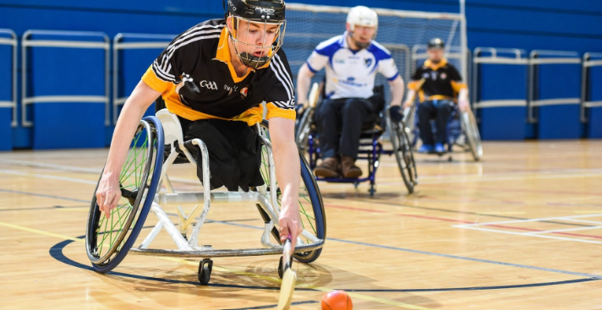
Disability and Special Needs Policy

INSERT YOUR CLUB LOGO HERE

Introduction

[Insert club name] is committed to the inclusion of all persons with a physical or mental impairment that has a substantial and long-term adverse effect on a person’s ability to carry out normal day-to-day activities, from here on referred to as a disability.

policy

This policy should be read in conjunction with the Club Equality Policy

As such our club will:

- Provide a welcoming and open atmosphere for disabled club members
- Provide a programme of activities for disabled club members
- Ensure that all club facilities are disability friendly and adhere to the relevant legislation in reference to disabled access.
- Ensure club facilities are open to use by Special Needs Schools or other community groups who cater for persons with a disability
- Attend Ulster GAA CPD courses on disability, special needs and the promotion of disabled games
- Provide a programme of disabled games in conjunction with other local GAA clubs in the area
- Ensure that positive images and role models of disabled people and disabled coaches will be represented in all resources, promotional and publicity material
- Appoint an Executive Level officer with responsibility for linking with special schools and catering for members with disabilities
- Share good practice with other GAA/Sports Clubs
- Develop links with other sporting clubs through the Local Sports Council/Partnership to cater for disabled members
- Link with relevant statutory bodies in the area of disability

declaration
This document has been approved by the Club Executive Committee and serves as the working Disability and Special Needs Policy of [Insert Club Name].

Club Chairperson

Signed: ______________________________ Date: _________________________

Club secretary

Signed: _______________________________ Date: ________________________

