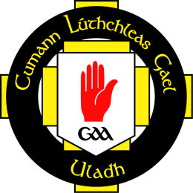 |  | Ulster Hurling Road Show  Saturday 25th Feb  Dunloy GAC, Co.Antrim
Time | Clar An Lae
9:30am | Registration
9:45am  -  10:30am | Session 1a  (Indoor 3G Pitch)  Turning low numbers into high quality  ‘Stop preaching to the converted’  Michael McCullough & Ronan McWilliams (Ulster GAA)
10:45am  -  11:30am | Session 2a  (Indoor 3G Pitch)  Coaching Specialist Skills  Goalkeeping, Free Taking & Sideline Cuts  Shane Elliott (Derry Senior Hurling Coach & Former Antrim Goalkeeper)  &  Ruairi Convery (Ulster GAA, Derry Senior Hurler) |  | Session 2b  (Viewing Area)  Diet & Supplements  ‘To take or not to take’  Michael Conlan (Personal Trainer, Current Ballinderry, Former Derry Goalkeeper
11:45am  -  12:45pm | Session 3  (indoor 3G Pitch)  Hurling - Keep it simple, practical and most importantly effective.  Gregory O’Kane  (Ulster Hurling Manager & Antrim Senior Hurling Coach)
1:00pm | Light Lunch

The Cost is £10.00 per Coach Attending
Or
6 Coaches for £50.00
+ An  
Personalised Club Helmet for all Clubs attending

• Places can ONLY be reserved through advanced payment
• In order to book your place, complete the form below, along with payment (Cheques can be made payable to ‘Ulster Council GAA’) and return to:
Ulster Hurling Roadshow
Ulster GAA Offices
8-10 Market St
Armgh
BT61 7BX
OR
contact Kevin Kelly on (+4428) 3571 7180 to book via Credit/Debit Card
For Further information please email kevin.kelly.ulster@gaa.ie
--------------------------------------------------------------------------------------

Club Name |  | No of Delegates
Club Contact |  | 6 for 5 offer: |  | Y |  |  | N
Address 1 |  | Name(s) of Delegates Attending
Address 2 |  | Name 1
Address 3 |  | Name 2
County |  | Name 3
Post Code |  | Name 4
Contact No |  | Name 5
Email |  | Name 6

--------------------------------------------------------------------------------------
A Confirmation letter will be sent to your Club Contact on receipt of payment.

