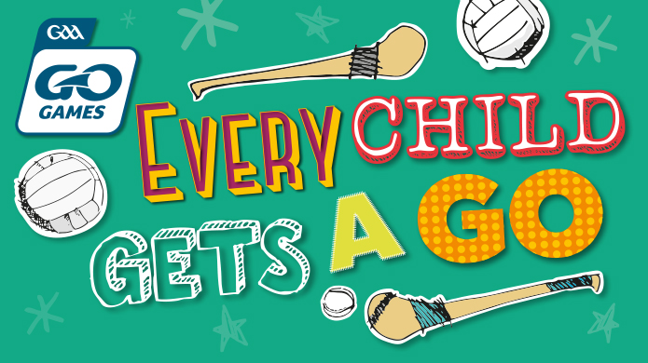
GAA Go Games

Go Games are small-sided versions of Hurling and Gaelic Football which have been devised for children up to and including 11 years of age.
GAA Annual Congress 2013 saw the passing Rule 6.26 to change the Association’s policy of Go Games. Subsequently, the supporting policy document was drafted by the Games Development Committee and was approved by Central Council. This forms the basis of national policy, as an extension of Rule 6.26, and is effective as of January 1st, 2014.
The following are the key underpinning principles of Go Games:
• All participants play in the full game.
• Participant needs are catered for, where possible, on the basis of two year age cohorts i.e. U.7, U.9 & U.11 in a manner consistent with the ethos of Go Games.
• Activities are structured in a manner which optimises the level of fun, friendship, fair play and achievement derived by participants.
• Participants train and play in a safe, supportive and stimulating environment where they are encouraged to risk error, to learn and to derive maximum enjoyment from their involvement.
• Players master the basic skills of Hurling and Gaelic Football and experience the sense of accomplishment, which derives from acquiring playing proficiency on the left and right hand side of the body.
• Everybody involved in Go Games, whether as players, parents/guardians, spectators, mentors, teachers, officials etc., should adhere to the key underpinning principles and give expression to the GAA ‘Give Respect, Get Respect’ initiative.
Organising Go Games
Go Games may be organised on a blitz basis. Go Games may be organised by a Club, Primary School or at an Approved GAA Centre on an internal (i.e. single unit) or external (i.e. multiple unit) basis.
Playing rules can be adapted to meet localised needs.
Go Games Regulations
The following Go Games Regulations shall apply:
Go Games are subject to general rules of the Association.
Teams shall be a maximum of 7-a-side at U.6 & 7, 9-a-side at U. 8 & 9 and 11-a-side at U.10 & 11 age levels.
Participants may play up one age grade i.e. U.7 may play at U.9 level; U.9 may play at U.11 level; U.11 may play at U.12 & U.13 age levels.
No provision is made to publish scores, to play on a knock-out basis nor to include semi-finals, finals etc.
No provision is made to present trophies, cups etc. Where certificates/medals are presented in lieu of participation, the same certificate/medal must be presented to every participant.

