Ulster GAA
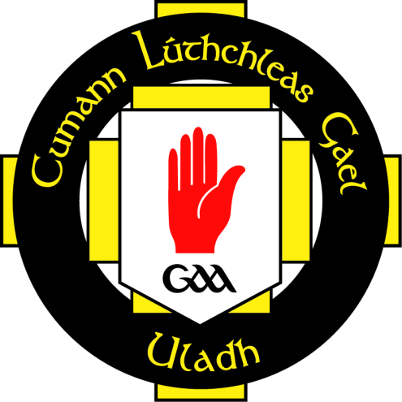
Club Coaching Audit

Club Name
Please complete and Return to:  Creating Sustainable Club Coaching Structures  c/o Diarmaid Marsden  Ulster GAA,  8-10 Market Street,  Armagh,  BT61 7BX  or email to:  Diarmaid.marsden.ulster@gaa.ie |  | Club Contact
 |  | Role
 |  | Address
 |  | County
 |  | Postcode
 |  | Contact No
 |  | Email

- Club Details
Club Name: |  | Club Address:
Email: |  | County:
Telephone: |  | Post Code:
Chairperson Contact Details |  | Secretary Contact Details
Name: |  | Name:
Email: |  | Email:
Telephone: |  | Telephone:

Coaching Administrator / Juvenile Secretary/ Youth Officer Details |  | Children’s officer Contact Details
Name: |  | Name:
Email: |  | Email:
Telephone: |  | Telephone:

- Club Teams
How many teams does your club cater for and how many players do you have at each level?

Children Teams  (Up to U12) |  |  | Youth Teams  (U14 – U16) |  |  | Adult Teams  (Minor – Senior)
Gaelic Football (Mens) |  |  | Gaelic Football (Mens) |  |  | Gaelic Football (Mens)
Hurling |  |  | Hurling |  |  | Hurling
Camogie |  |  | Camogie |  |  | Camogie
Ladies Football |  |  | Ladies Football |  |  | Ladies Football
Handball |  |  | Handball |  |  | Handball
Rounder’s |  |  | Rounder’s |  |  | Rounder’s
Player Numbers  Children  (Up to U12) | Male | Female | Youth  (U14 – U16) | Male | Female | Adult  (Minor – Senior) | Male | Female
Under 8 |  |  | Under 13 |  |  | Under 17
Under 9 |  |  | Under 14 |  |  | Under 18
Under 10 |  |  | Under 15 |  |  | Under 21
Under 11 |  |  | Under 16 |  |  | Junior
Under 12 |  |  | Other/Specify |  |  | Intermediate
Other/Specify |  |  |  |  |  | Senior
 |  |  |  |  |  | Reserve
 |  |  |  |  |  | Other/Specify

- Club Facilities
What facilities does your club use? (please state numbers of each facility)

Facilities | Owned | Hired | Cost of Hire | Condition | Is Facility Shared
Playing Pitches
Training Area
All Weather Pitch
Indoor Hall
Gym/ Weights Room
Hurling Wall
Handball Wall
Clubhouse
Floodlit pitches
No of Dressing Rooms
No. of dressing rooms with showers
Portable Goals
Coaching Equipment Store

- Club Coaching Structure

Yes | No
Does your Club have a coaching and games committee?

If Yes – Please specify what personnel are included in this committee and how often do they meet

Yes | No

Does your Club have a link with the local Primary School?

If Yes – Please specify details of the link – coaching, shared facilities, noticeboard etc..

Yes | No

Does your Club have a link with the local Secondary School?

If Yes – Please specify details of the link – coaching, shared facilities, noticeboard etc..

Yes | No
Does your Club run an official Cul Camp or club summer camp?

If Yes – Please specify details of the camp(s) and number of children who usually attend

Yes | No
Does your Club have a Coaching session template which coaches work from?

If Yes – Please specify what the template consists of

Yes | No
Does your club follow the Long term Player Development Pathway (LTPDP)?

If Yes – Please provide details?

Yes | No
Does your Club have a Coaching Plan which Coaches work from?

If Yes – Please specify how this plan was drafted and how it is monitored and evaluated

Yes | No
Does your Club provide Coach Education opportunities for Club Coaches?

If Yes – Please provide details

Yes | No
Does your club run internal competitions and / or friendly games?

If Yes – Specify?

Yes | No
Does your Club have a strategy for recruiting coaches?

If Yes – Please specify details of how your club recruits and appoints coaches

- Coach Education
How many Active (currently coaching) Coaches are there in your club and what levels are they qualified at?
Gaelic Football | No. | Hurling | No. | Ladies Football | No.
No Qualification |  | No Qualification |  | No Qualification
Foundation Level |  | Foundation Level |  | Foundation Level
Award 1 Child |  | Award 1 Child |  | Level 1
Award 1 Youth |  | Award 1 Youth |  | Camogie | No.
Award 1 Adult |  | Award 1 Adult |  | No Qualification
Award 2 (C/Y/A) |  | Award 2 (C/Y/A) |  | Foundation Level
Other/Specify |  |  |  | Level 1

Please use the following box to provide details of any other relevant information regarding coaching and games in your club – successes, issues, vision for future, problems………

