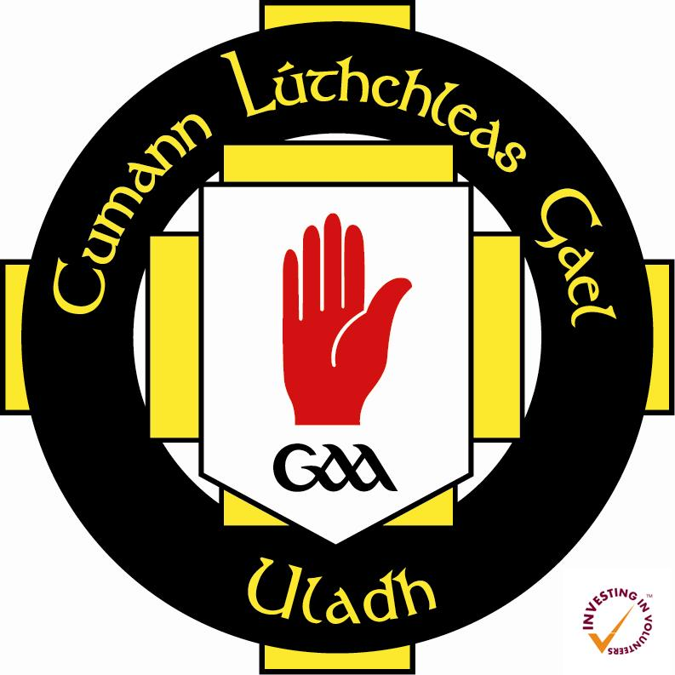

Gaeilge sa Chlub 2015/16

Rules and Regulations

- This scheme is open to current GAA members only within the province of Ulster.
- All applications to Gaeilge sa Chlub must be signed by the current club secretary or chairperson.
- Applications are made directly to Comhairle Uladh CLG, through Volunteer Development and Policy Officer sharon.haughey.ulster@gaa.ie
- Applicants to Gaeilge sa Chlub must first apply directly to the university in question in order to gain a place on the Diploma in Irish Language course. In the case of the University of Ulster, contact Mrs Ros O’Hagan for further details: r.ohagan1@ulster.ac.uk or call 02871375277. It is possible to apply online at: www.ulster.ac.uk/applyonline. Choose the ‘Taught UG Programme’ option.
- Only registered students can access this funding. In the case of the University of Ulster, the centres of learning are at Belfast (York St), Cookstown (Burnavon), and Magee campus, Derry.
- Successful applicants to Gaeilge sa Chlub will receive up to 50% reduction in the course fee (£832.80). No payment is received by individual applicants.
- Students must pay the rest of the fee directly to the University at time of registration (21 September deadline) in order to validate their scholarship.
- Scholarships are issued on a first come, first served basis.
- Comhairle Uladh may request applicants to attend a short interview before scholarships are granted.

