  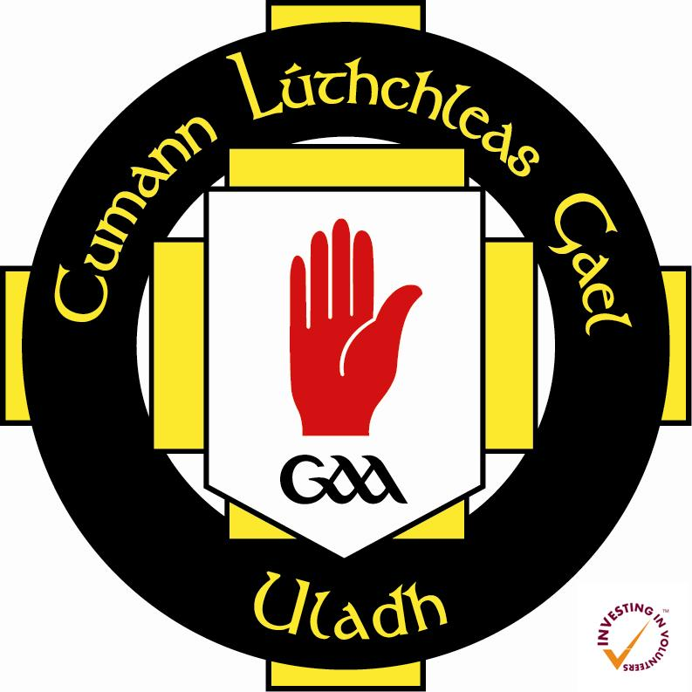

Foirm Iarratais / Application Form

Name:

Address:

Telephone:

Email address:

Date of Birth:

Club:

GAA Membership Number:

Describe your role in the club:

Why are you interested in doing the Diploma in Irish Language?

Previous qualifications in Irish:

Signature of Applicant:

Signature of Club Secretary or Chairperson:

Seoltar foirmeacha chuig Comhairle Uladh / Forms should be returned to Ulster GAA:

sharon.haughey.ulster@gaa.ie

Sharon Haughey-Grimley, Gaeilge sa Chlub, Ulster GAA, Ceannáras Uladh, 8-10 Market Street, Armagh, BT61 7BX