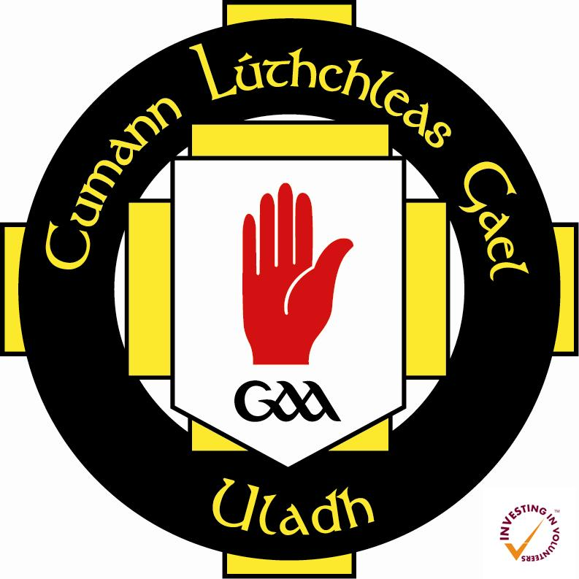

Gaeilge sa Chlub 2016/17

Rules and Regulations

- This scheme is open to current GAA members only within the province of Ulster.
- All applications to Gaeilge sa Chlub must be signed by the current club secretary or chairperson.
- Applications are made directly to Comhairle Uladh CLG, through Volunteer Development and Policy Officer fionntan.odowd.ulster@gaa.ie
- Applicants to Gaeilge sa Chlub must first apply directly to the university in question in order to gain a place on the Diploma in Irish Language course. In the case of Ulster Univeristy, to apply online select Part-time: Apply online link at ulster.ac.uk/apply/how-to-apply#ug to register and choose Taught UG Programme to apply OR contact the School Secretary, Mrs Ros O’Hagan: r.ohagan1@ulster.ac.uk or call 028 7137 5277.
- Only registered students can access this funding. In the case of the Ulster Univeristy, the centres of learning are at Belfast (York St), Cookstown (Burnavon), and Magee campus, Derry.
- Successful applicants to Gaeilge sa Chlub will receive up to 50% reduction in the course fee (£859.20). No payment is received by individual applicants.
- Students must pay the rest of the fee directly to the University at time of registration (19 September deadline) in order to validate their scholarship.
- Scholarships are issued on a first come, first served basis.
- Comhairle Uladh may request applicants to attend a short interview before scholarships are granted.

