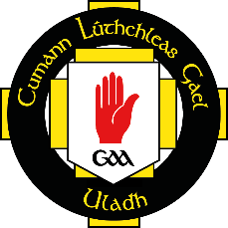
Cumann Lúthchleas Gael
Comhairle Uladh

2018 FinTrU Ulster GAA Football Inter-Firms
Application Form
A IARRTAS (Application) - to be completed by club

Team Name ……………………………………………………… Colours …………………………………………………………

Competition: Men Senior/Intermediate □ Men Junior □ Ladies (one section) □
Sat 3rd November Sat 10th November Sat 10th November
Entry Fee: €300 / £275 €300 / £275 €50/£50

(Entry Fee for Men competitions includes GAA Player Injury Cover at €200 per team)
(There is no Player Injury cover for the Ladies competition, teams should arrange their own cover)
For BACS details for electronic payment contact niall.muldoon.ulster@gaa.ie

Contact Info
Name ………………………………………………………………
Address …………………………………………………………….
………………………………………………………………
………………………………………………………………
Phone No ………………………………………………………….
Active Email ……………………………………………………...
Sínithe ……………………………………………………………… Dáta ………………………………………

Application forms must be returned to Comhairle Uladh no later than 4:00pm on Friday 20 October 2018
to Niall Muldoon, Ulster GAA, 8-10 Market Street, Armagh, BT61 7BX or niall.muldoon.ulster@gaa.ie
B CEAD AGUS DAINGNIÚ (Permission and Ratification)

The above application has been approved by Comhairle Uladh and is hereby acknowledged.

Sínithe ……………………………………………………………… (Comhairle Uladh)

Data ……………………………………………..

