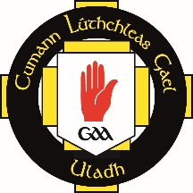
ULSTER GAA CLUB FOOTBALL LEAGUES
2020 APPLICATION FORM

A | IARRTAS (APPLICATION)
CLUB: |  |  | COLOURS:
CONTAE: |  |  | ACL DIV (2020):
GRADE: | SENIOR | INTERMEDIATE |  | JUNIOR
We, the undersigned, wish to make an application to Comhairle Uladh, to enter the 2020 Ulster Club Football League.
We enclose a non-refundable cheque for €150/£130 (made payable to Ulster GAA)
CLUB CONTACT INFO
Club Secretary:
Phone Number:
Club Email:
Sínithe:
Dáta:
- It is proposed to run the group stages on a regional basis, depending on the numbers of applications received, with the competition commencing on Sunday 26 January 2020.
- Application forms with the appropriate fee must be returned to Comhairle Uladh by 12noon on Monday 06 January
B | CEAD AN CHOISTE CHONTAE (COUNTY COMMITTEE APPROVAL)
The above application has been approved and I enclose cheque for €150/£130 Registration Fee
Contae:
Sínithe Rúnaí:
Dáta:

Section A to be completed by Club and forwarded, with fee, to County Committee.
Section B to be completed by County Committee and forwarded with fee to Comhairle Uladh

Completed forms should be returned to;
Niall Muldoon niall.muldoon.ulster@gaa.ie
Ulster GAA, Games Administration, 8-10 Market Street, Armagh, BT61 7BX

