Comhairle Uladh
Ulster Council G.A.A.

2 AIBREANN 2020

To Whom it Concerns

I wish to confirm that in accordance with the “Additional 14-day restrictive actions” to limit the spread of Covid-19, the club facilities at x location are closed and notices, confirming the closure, are displayed at the entrance.

Insert if applicable – The Community Employment Scheme personnel (or other contactor / person) who look after the day to day maintenance and upkeep of the facility have been told, by their Sponsor, to stay at home for at least the next 14 days.

At the request of Club / County GAA Management Committee, Persons name has agreed to undertake essential services at the facility, in a voluntary capacity, for the duration of the closure. The essential services include security, grass cutting and general maintenance.

Trusting this clarifies the position.

Le meas
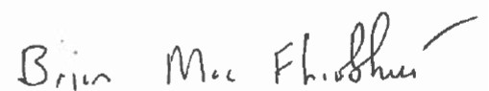

Brian Mac Fhíobhuí
Rúnaí/Chief Executive Officer
CLG Comhairle Uladh

Brian Mac Fhíobhuí, Rúnaí, Comhairle Uladh
8-10 Sráid an Mhargaidh, Ard Mhacha 8-10 Market Street, Armagh, BT61 7BX
Tel: 028 (048) 37521900 Email: brian.mcavoy.ulster@gaa.ie Web: www.ulster.gaa.ie

