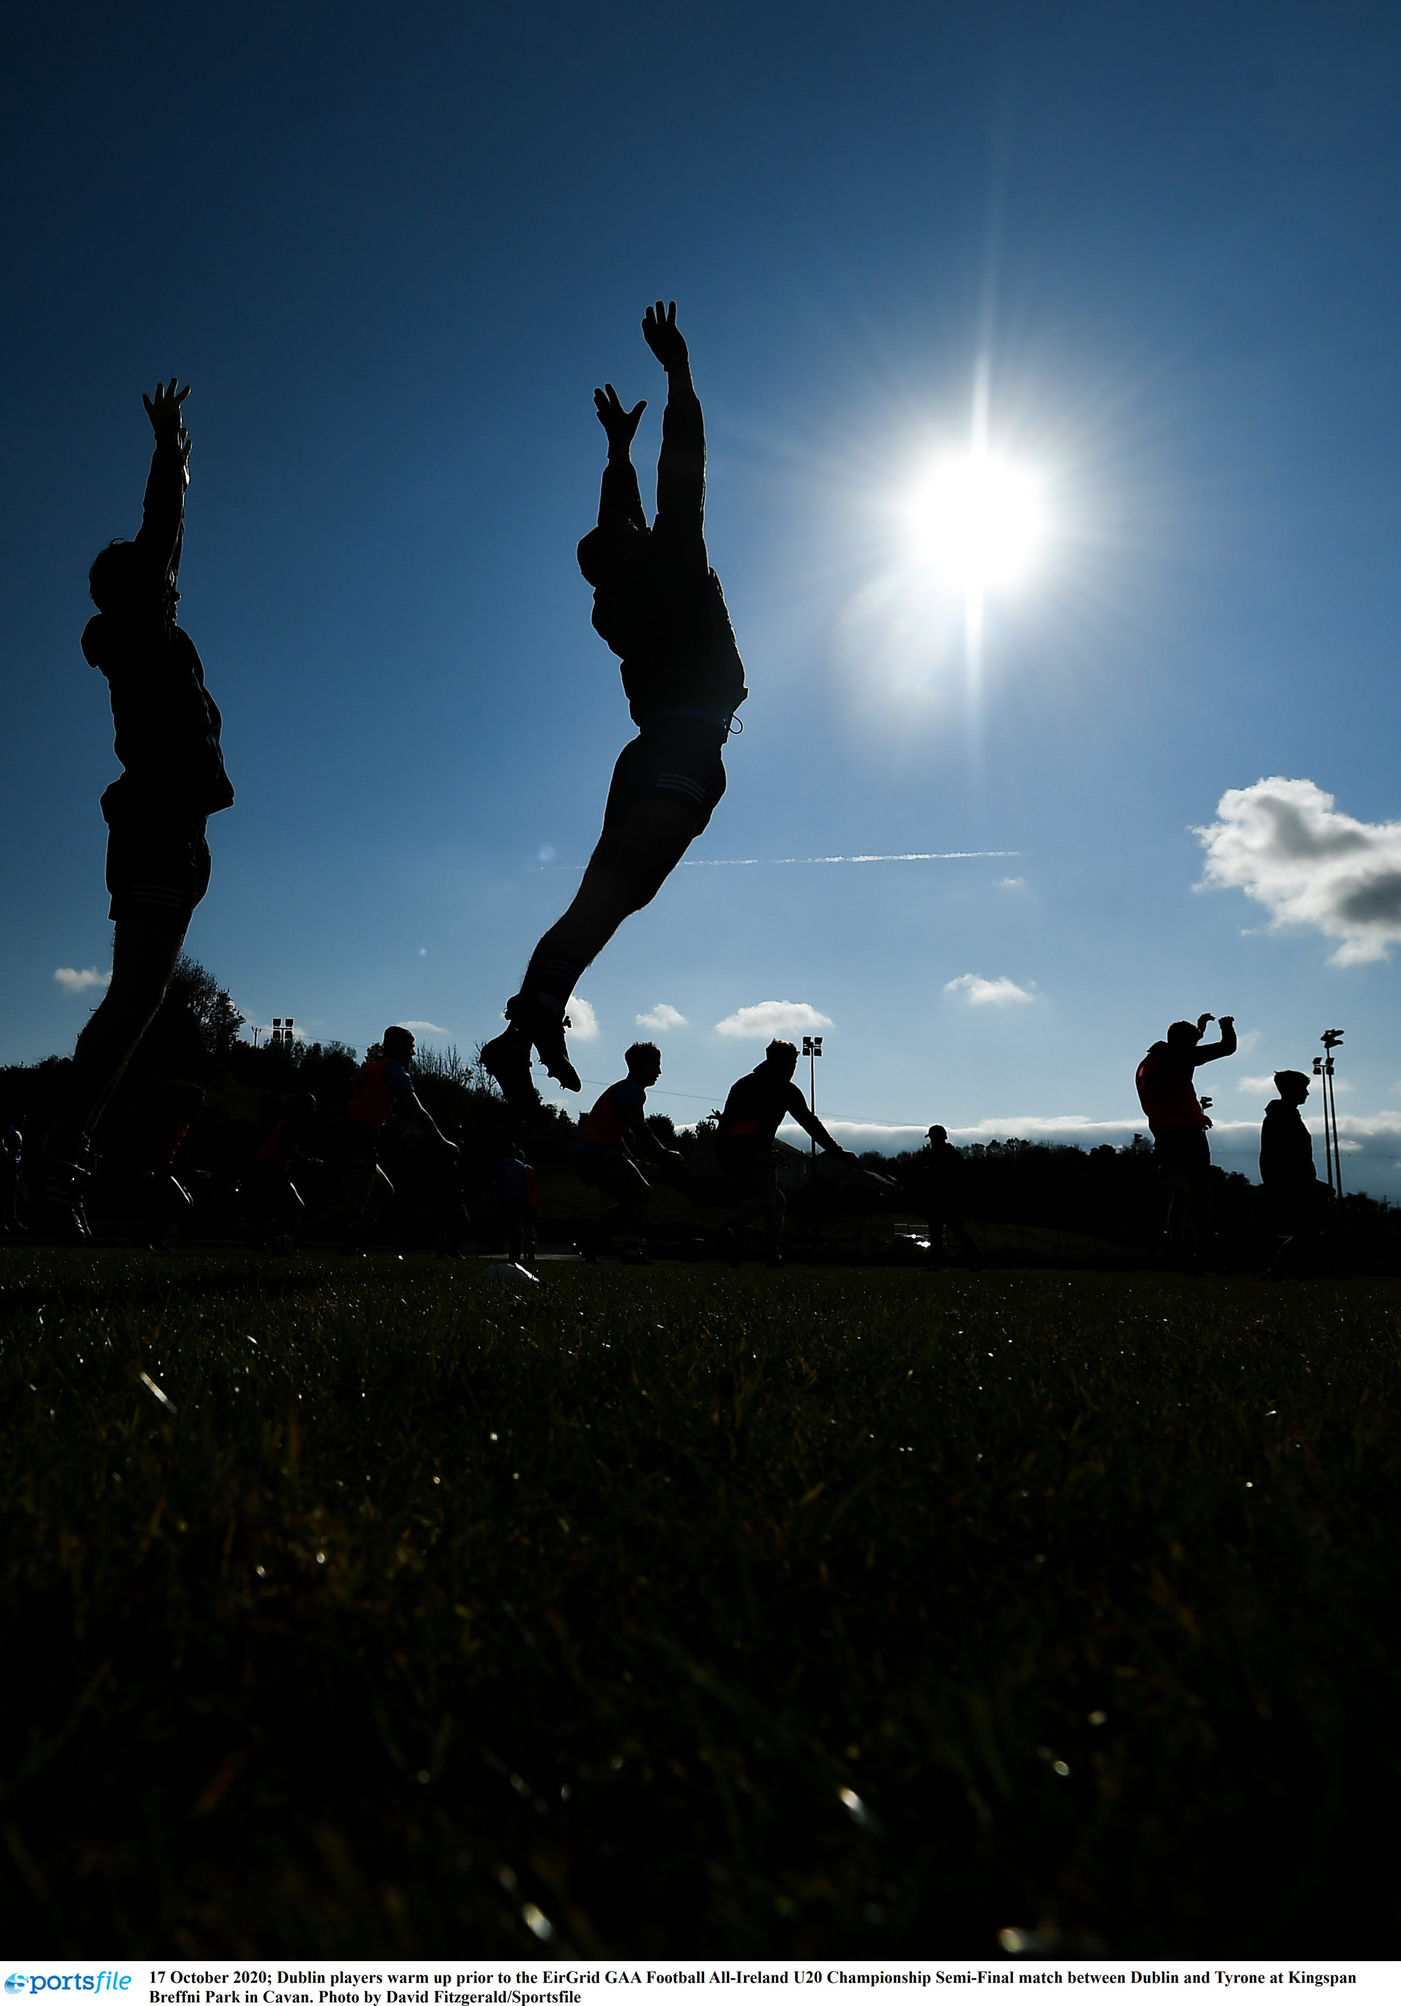
DISABILITY AND INCLUSION

POLICY AND PLAN
2021-2024

Foreword
The GAA is an integral part of the fabric of our society. Society trusts us to work with, nurture and develop everyone who want to play our games. Our Association promotes and supports the core values of community identity, amateur status, inclusiveness, respect, player welfare and teamwork and volunteerism (FIS SHOILEIR - Strategic Plan 2021). Respect and inclusiveness are two key values that are reflected in this document and relevant to this paper disability and inclusion.

Involving people in our games is a challenge due to the nature of what we do. However, we have moved a long way in the last five years to ensure that the games are adapted and suitable for people with all abilities and ages.

The most recent report from the GAA, the Talent Academy and Player Development Review Committee (2019), reviewed youth player development in Gaelic Games across the 32 counties. There was extensive consultation through 2019 again reinforcing the need for a more radical approach to managing player development. One important element is the emergence of a structured player pathway. It now presents a framework where we can start to structure our delivery across disabilities to ensure that everyone is included.

There are many stakeholders in the development pathway that include club, school, further and higher education, academies, county teams and provincial and international teams. For the first time the player development pathway in wheelchair hurling has been completed with activity from club to county to province to International stage.

There has been an increased interest from parents and guardians and the demand from many stakeholders for increased education around certain disabilities. The GAA for ALL programme has been supplemented by training and development in autism and ADHD. One of the biggest challenges we face is to coordinate the gallant efforts of all of these stakeholders so that they complement and not conflict with one and another.

This policy is a reflection of the work that we have done to date and emphasizes the central plank of keeping our games and opportunities open to everyone across the Province. It is proposing that the stakeholders start to engage more with us and with each other. There are tremendous opportunities now with equipment available within local councils. This increased provision requires the development and embedding of GAA for ALL club and community coaches, who can begin to use their knowledge, skills and competencies and undertake a more hands on approach to player development. It is recognized that a focus on the club is a huge challenge in terms of resources and expertise, but that regional hubs can be effective as reflected by the four hubs established by Ulster GAA.

Schools also have exclusive access to young people and young players with disabilities and programmes to increase awareness and to engage in future leaders could potentially make an impact on player development programmes. Exciting times that will inform our strategy going forward.

EXECUTIVE SUMMARY
- This document reflects on where Ulster GAA has come from over the last 6 years in delivering a disability and inclusion programme.
- In an attempt to address the inclusion of players both physical and learning difficulties, many initiatives have been driven both at provincial, county and club levels.
- Moving forward this work will continue, and it will develop further to actively engage and encourage female participation in the activities. We will engage with the Camogie and Ladies football to encourage female participation.
- One key pillar in the program is to increase awareness among peers and siblings. The family participation days and the school and further and higher education awareness days have added significantly to this and should be encouraged further.
- Formal competitions for wheelchair users are well organized at inter provincial levels but we are striving to have local competitions and we need to engage able bodies to ensure that we have the numbers to allow the games to proceed. The support of clubs and schools and family members is essential for this progress.
- Sustaining any system requires volunteers. In these cases, the players have their family members with them to support then on the day at events and training. Maximizing this support and asking them to engage and become involved in coaching and mentoring players will help to build sustainability into the programme.
- Providing opportunities for coach education is central to the strategy moving forward. There are several challenges around this area, and we have found that there is a great demand for support and education. Player with physical abilities need to be encouraged to take the education programmes and make a contribution back into the system. Support and family personnel and full-time coaching staff also need to be in a process of constant education and upskilling.
- The embedding of a player pathway and the development of overseas opportunities was a very welcome initiative in 2019. Opportunities with Scotland, England and Wales should be explored with potential to develop initiatives overseas with our twinned partner Canada.
- Further promotion of the games and initiative through active social media and newspapers and TV is welcomed and the opening up of the activities to people from a non-traditional GAA background will be encouraged.
- Promotion and increasing awareness with County Boards is central as they work closely with our clubs. Active support through their inclusion committees would provide a platform for discussion and debate and the generation of new ideas.

Content
foreword 3
Executive Summary
- Introduction
- The Player Pathway
- Policy to Practice
- Moving Forward
- What does it Look like in Practice?.... DISABILITY AND INCLUSION DEFINED
  - Coach Recruitment and Retention
  - Player recruitment and Talent Management
  - Skills and athletic development in the pathway
  - Participation Opportutnies
  - Performance Opportunties
  - Work Plan
- Conclusion

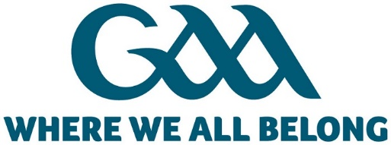

Introduction
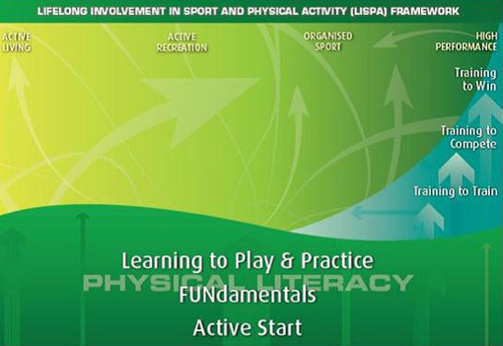
Ulster GAA has been consistently applying the Lifelong Involvement in Sport and Physical activity (LISPA) model to their programme and player development for over 10 years. This was an evolution from the LTAD model that allowed us to structure our programmes and our support across the spectrum. LTAD allowed us to identify the gaps and start to strategically pinpoint areas that needed support. One key area was that of Disability and Inclusion.
The key principles and programme that we have been engaged in so far are included the following

- Wheelchair Hurling has become a flagship programme. It has provided excellent participation opportunities within hubs, clubs and schools. The programme has also provided opportunities for those that excel through the Inter Provincial and All Ireland series of competitions. It was a huge step when we secured a place at the World Floorball Championships and sent an Irish Team with three Ulster representatives.
- Players with physical and learning abilities have been targeted as a group. Coaching is delivered within the special schools and with community groups There are training and playing opportunities within counties in preparation for games at half-time during the championship season. There are now participation opportunities to play at GAA for ALL days in Croke Park against other counties and in Clones at Ulster semi-final games. A special competition is also organised and run in Antrim at the Creggan Club. This allows teams from counties to come and represent their county and compete.
- Education provides the third strand of our policy. In its broadest sense we aim to encourage our volunteers and our athletes to play but also to become coaches, referees. Many have now engaged in our GAA for ALL training programme. In addition, some have taken the Foundation Coaching awards and a number of sell out workshops on Autism and ADHD (supported by Disability Sport NI) have been delivered. To sustain the programmes and the drive, its essential that volunteers engage and support the initiatives. The final strand of the education programme is to raise awareness and bring the projects into the schools. Where a young person is in a chair, we engage with their class and allow them to have this experience and grow their appreciation of the challenges. Based on where we are then our vision and objects moving forward are as follows:

Vision
“To provide opportunities and support in an inclusive environment, that encourages people of all abilities to engage and enjoy our programmes and excel at their level.”
Our Mission is to educate and support our volunteers coaching in schools, clubs and counties and to provide opportunities for those with a disability within all communities to enjoy our games.
Four key objectives are set out.
- Educate administrators, peers, coaches, parents and guardians.
- Embed the player pathway and provide progressive opportunities.
- Increase awareness in schools and clubs and community groups
- Engage volunteers to support programmes through administration and refereeing
These objectives will drive our policy and put it into practice taking into account the player pathway that all GAA athletes follow from participation to performance.

PLAYER PATHWAY
- The GAA Review Committee (2019) adopted the Australian Institute for Sport (AIS) FTEM framework (Foundation, Talent, Elite, Mastery) to provide a structure to help examine our needs, policies and curriculum in planning and supporting players in the pathway.
- “The AIS has developed the FTEM framework to capture these different pathways…provides a practical tool to assist stakeholders …in reviewing, planning and supporting athlete pathways.”
https://www.sportaus.gov.au/ais/ftem
- Our key focus moving forward is providing participation opportunities and engaging with other stakeholders who have access to athletes and who want to try different sports.
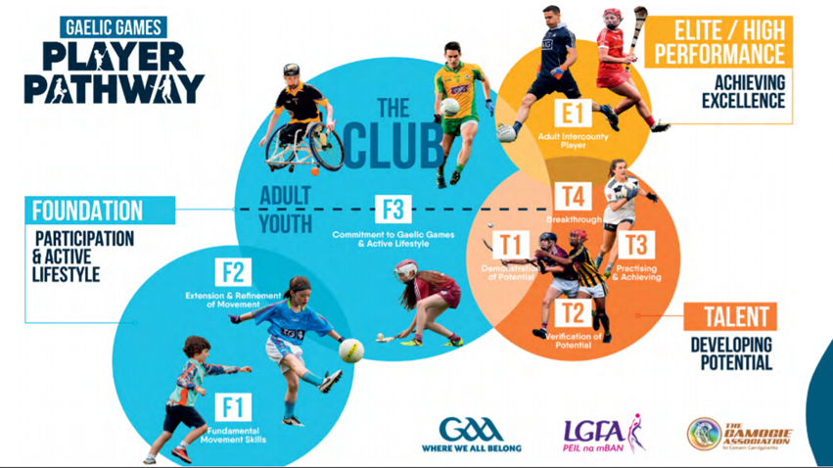
- Using the framework, the focus is initially on having fun, with players working their way through the F1, F2 and F3 phases of the framework. What does this mean for the players? Getting out, meeting people, developing their social skills and their confidence. Being in an environment where they can share and compete and get a physical workout.

- For some there may be the opportunities to progress to play for the county, province and internationally while working their way through the T1,T2 to E2 phases. A number of our existing T4 players are already involved with other sports and are moving into the E1 phase.
- As players move through the stages the expectations and the demands increase at the different stages for players, parents and guardians and coaches. There is more commitment and a need to be physically strong. The challenge is to open door for these adults and young people with other stakeholders to allow them to access local authority and club facilities to help enhance their performance.

POLICY TO PRACTICE
To provide a guideline for programme development and the education and progression of players coaches and officials- the following broad principles should be applied:

Embed the player pathway and provide progressive opportunities.
- As we increase our capacity in coaching and volunteer support and get more young people and adults involved in our programmes, our challenge has to be to develop local school and club-based competitions. We already see able bodied players taking part with their friends who have a disability. Progressions to county and Provincial teams provide the pathway and ultimately the development of more international opportunities.

Increase awareness in schools and clubs and community groups
- Positive marketing of programmes in schools, clubs and community groups increases awareness. The use of social media and posters has been great for increasing awareness of the wheelchair hurling programme. The use of the player pathway posters in clubs and the roadshows in schools and colleges and the half-time games in championships and at Ulster Championship semi-finals has also increased awareness. To really take this to the next step there is a need for active engagement and investment.

Engage volunteers to support programmes through administration and refereeing
- All programmes need people to drive them. At present the current allocation of staff is not sufficient to make any more impact. Moving forward there is a need to argue for resources to make these programmes integral to the work of the GAA. A full-time resource can generate volunteer engagement and develop new initiatives around refereeing and encourage administrators to support the initiatives.

Educate administrators, peers, coaches, parents and guardians.
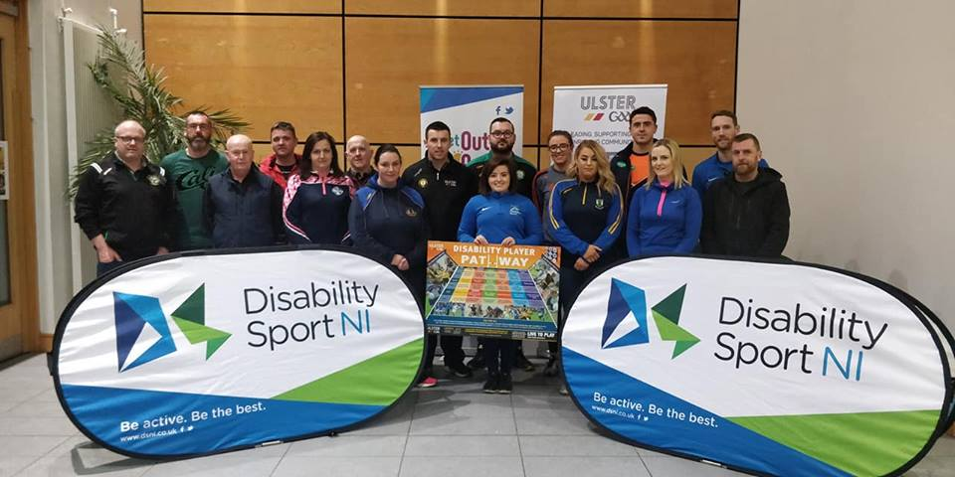
- There is still within the broader GAA Community a lack of knowledge around the programmes and the challenges in this area. Like many initiatives that run, the administrators find out by chance. Peer and Coach education needs to be expanded and engagement of the utilization of parents and guardians within the system needs to be developed further.

MOVING FORWARD
- With all strategies we reflect on what we have done well and what we could do better, but also set an agenda about where we want to go next. Much of what we have been doing needs to continue but moving on we need to extend ourselves, our volunteers, our athletes, our administrators and our coaches. Reflecting on our vision and objectives we need to see what this will look like on the ground.
- Moving forward we are challenged to retain what is already on the ground and grow this with new initiatives that are reflective of our vision and objectives

- To achieve this work on the ground moving forward we will promote the Good Practice through the Sports Inclusion Model (SIM). Clubs and activity sessions: Clubs and activity sessions will be encouraged to promote inclusive principles. Coaches and volunteers: will be provided with education opportunities to increase knowledge and awareness and help them to develop confidence in this area. Health and education sectors: will be engaged and recruitment of athletes can take place directly from this sector. We can also support policy makers and practitioners to be confident and competent to meet the needs of all participants with a disability. Working with the Key partners we will encourage them to adopt policies and procedures that have a positive impact on delivery and ensure that participants with a disability are considered and included.

What does it look like in Practice?
- Developing programmes across the needs of participants is a difficult challenge. Many volunteers don’t have the skills set or the knowledge to deal with young people or adults with physical and / or learning difficulties. Nevertheless, we are challenged to provide opportunities in a number of ways:
  - Mainstream Participation: Players with disabilities training and competing in a mainstream club. (e.g A deaf footballer or an upper limb amputee playing for a mainstream club.
  - Integrated Participation: Disabled and non-disabled people participating in the sport with some adaptions to rules or equipment. (e.g. Wheelchair Gaelic Football).
  - Disability Specific Participation: Athletes with a disability competing in a competition solely for that particular disability group (e.g. Wheelchair Hurling or learning disability Gaelic football).
- To support these, we need coaches and volunteers and we need the help and co-operation of teachers in schools and staff and volunteers in clubs and counties. .
coach Recruitment, DEVELOPMENT and Selection
The challenge is
- Recruit coaches from out volunteer base, in particular through young leaders and future leaders programmes, athlete peers in schools and clubs, parents, guardians, siblings and teachers.
- There needs to be a structured education programme across these groups allowing them to expand their knowledge and skills.
- There also needs to be a reward and recognition programme not only for coaches but for the support people that the athletes have with them at training and games.

player Recruitment and talent management
The challenge is
- Recruit players into programmes that meet their specific needs. In so doing its essential to engage on a regular basis with parents and guardians and assess where they are at and any aspirations to move through the FTEM pathway.
- Where talent is identified, opportunities for a structured programme for development of the physical, psychological, technical, teamplay and nutrition and fitness parameters need to be implemented. Engagement by professionals in all areas of sports science and nutrition will help enhance the athlete’s performance.

PARTICIPATION oPPORTUNITIES
- We have set the challenge for more structured programmes of games. Provincial games are well embedded at this stage. The biggest challenge is to get the local Provincial (Ulster) competitions going forward at intercounty and inter club as well as schools-based competition inhouse and inter school.
- Logistically this is a huge challenge give the resources at our disposal. But a realistic challenge such as inclusive inter club blitzes and intercounty championships are a potential avenue for increasing formal participation.
PERFORMANCE OPPORTUNTIES
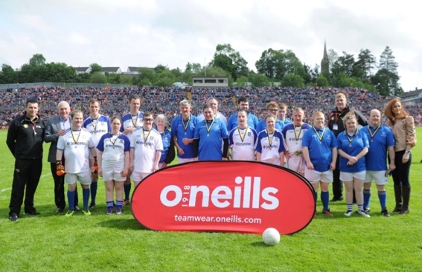
- Performance opportunities can now be enhanced. There is a great interest from community groups in the inter-county championship half - time games. Team are formally training for this opportunity to play at half-time. This has been expanded though a tournament and this now needs to be formalised.
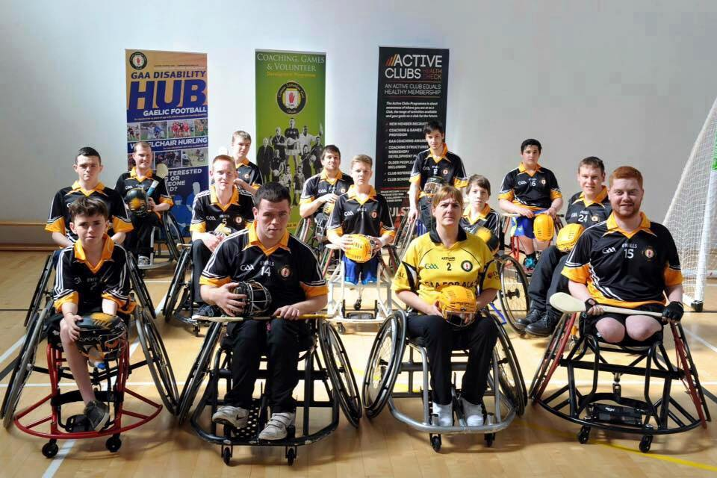
- Further development and embedding of the wheelchair and floorball games is required with other avenues explored to allow for international competitions.
- The expansion of the games programme is important with the Wheelchair football showing potential as an inter-Provincial and intercounty competition.
- We also need to explore female engagement and the potential to include camogie, ladies’ football and handball.
WORK PLAN
- Practical activity on the ground is where the real difference is made. At present we are under resourced to deliver what is being proposed. The programmes are wide and diverse and without the help of partners and other stakeholders we would be struggling to deliver.
- In a time of austerity and cuts, the support from partners such as Disability Sport NI may well be under threat. So, any work plan is developed under the knowledge that to make it work it needs investment and people.

Conclusion
- There are tremendous challenges around this area of work and at the same time the rewards are fantastic for athletes, families and the community.
- The merits of sport are well rehearsed and opportutnies create the environment where young people and adult can thrive, improve their fitness and well-being and make new friends.
- They meet challenges in the sporting environment, but they are none less than they do in their everyday lives.
- Ulster GAA has created a huge interest and have presented programmes that are well received. As we move forward the need to embed and expand programmes are met with the need to resource. We look forward to working with partners, athletes and other stakeholders to ensure a safe and inclusive sporting environment.
APPENDIX 1 WORK PLAN

- Educate administrators, peers, coaches, parents and guardians.

Objective | Planned Action | Output/Target
Coach Education and Training:  Develop and implement a disability coach education and training framework for Ulster GAA.  Disability awareness | To review and update the’ GAA For All’ workshop aimed at providing coaches with both theory and practical knowledge around the area of inclusion.  To develop and promote a Wheelchair Hurling specific workshop providing coaches with a basic knowledge of wheelchair skills, game adaptations and rules.  Tutor/Staff Training  To promote disability inclusion via schools and clubs | To have 4 to 6 courses delivered across Ulster on an annual basis  Develop course content and resources by Jan 2021.  Pilot course organised and final amendments made by Sep 2021.  Deliver 6 Wheelchair Hurling Workshops by March 2024.  Ulster GAA tutors/staff to be fully trained and in place to deliver GAA for ALL by Jan 2021.  Key Ulster GAA and DSNI Tutors to be involved in the development/delivery of the Wheelchair Hurling Workshop Pilot.  All Ulster GAA Staff, County Staff to have successfully completed GAA For All training by Jan 2021.  To provide an annual service to schools and clubs where by students and members are educated on disability and Ulster GAA’s disability sports via a disability awareness roadshow

- Embed the player pathway and provide progressive opportunities
Player Pathway | To agree and establish a player pathway for athletes with a disability, with specific focus on the following impairment groups:  - Learning Disabilities (football)  - Wheelchair Sports (Hurling)  To provide talented players with an opportunity to train and compete at a higher level.  (Learning Disability)  (Physical Disability) |  |  | Agree and formalise learning disability football rules by April 2020.  Competition/league framework and rules circulated to schools and community groups by May 2020.  Competition framework to be up and running by September 2020.  Special Schools League/competition structured successful implemented and embedded by October 2021.  To continue to support demonstration events at Ulster Senior Championships matches & disability activity days  Review existing structures supporting wheelchair hurling and distribute rules that are currently adopted for the game.  Establish bi-monthly training sessions for the Ulster Wheelchair hurling team.  Compete in national league and championships  Wheelchair Roadshows and taster sessions to attract new players  Establish 4 wheelchair hurling teams within Ulster to compete in 2 Provincial events annually by 2024  Annual inter county tournament  Participate in 2 national blitzes annually. Schools representation.  Wheelchair hurling players from Ulster considered for selection on international GAA wheelchair representative team
- Increase awareness in schools and clubs and community groups

Club Development |  | To encourage and support the inclusion of people with disabilities in all Ulster GAA clubs. | Circulate the agreed rules for Learning and Disability games through the club network.  Provide club coaches and volunteers with regular access to disability coach education and training opportunities.  Identify clubs currently providing regular training opportunities for players with learning disabilities and support as needed.  Target 6 suitable mainstream clubs to pilot LD programmes within their structure. LD Club league/competition developed.
Schools Development |  | To encourage and support the inclusion of people with disabilities in all Ulster Schools | Circulate the agreed rules for Learning Disability games through the schools network.  Provide awareness days for classes to educate peers on the challenges.  Develop internal blitz opportunities and inter school blitz opportutnies.  Target 10 schools per year.

- Engage volunteers to support programmes through administration and refereeing

Admin and refereeing support | To encourage and support volunteers both with and without disabilities to be involved in the delivery of programmes.  Develop opportutnies to train as referees | Actively recruit volunteers and have roles and responsibilities that they can deliver on.  Deliver education presentations to county and club administrators on this work.  Target each county board to deliver a presentation on inclusion and disability.  ‘GAA for ALL’ Officer in each County  Provide a training opportunity each year for volunteers to learn the rules and become referees.

