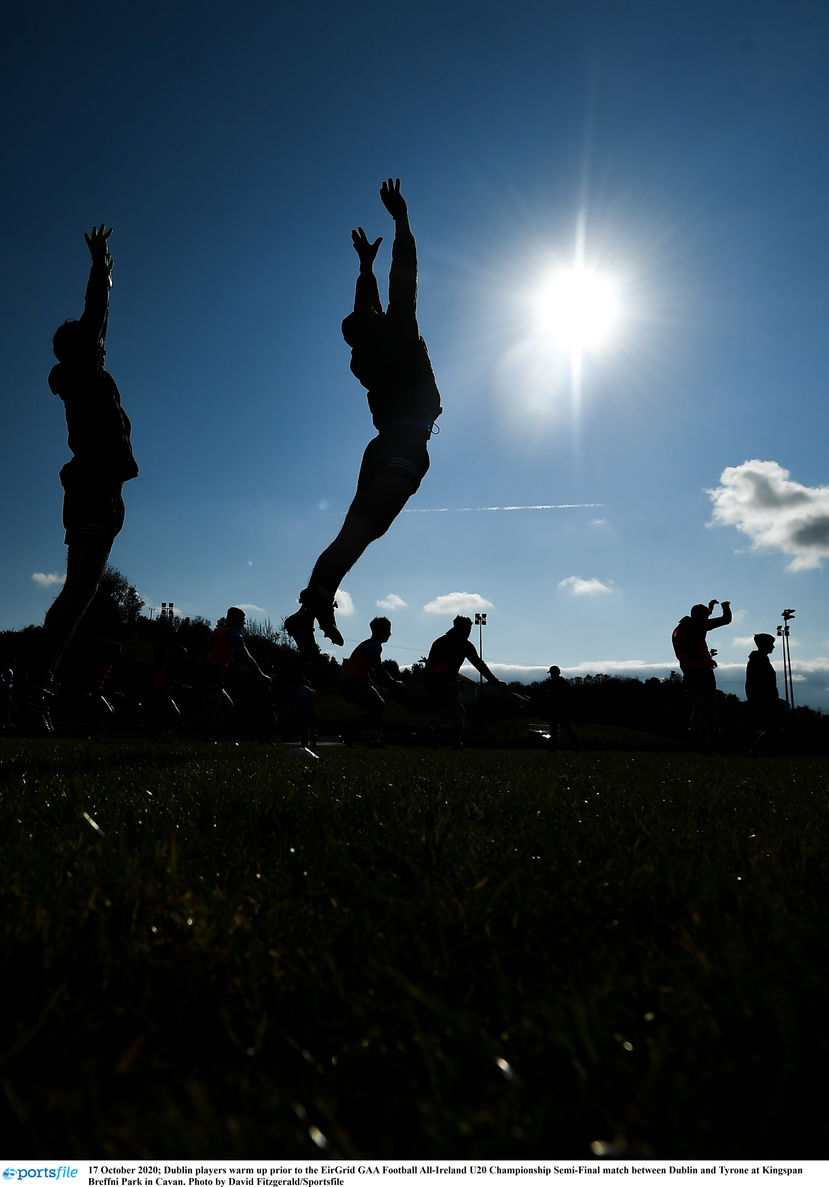

SPORT SCIENCE SUPPORT

POLICY AND PLAN
2021-2024

Foreword

The emergence of Sports Science as a tool to support player development and team preparation has grown gradually over the last ten years. This space is populated by a specialist graduates who bring a lot of expertise and knowledge to the physical and mental preparation of our players.

The model for team support has become very complex and the numbers in backroom teams has increase dramatically. The information provided is excellent. The results from fitness testing, the GPS feedback from games and training, live on the pitch to sideline heart rate information being relayed directly to the sidelines. In addition, there has been an increase in the use of video technologies to assess player strengths and weaknesses and to analyze both home team and opposition performances. Other applications have seen research on the use of blood to look at fatigue and burnout and performance and lifestyle programmes used to support the player and their welfare.

Sports Science has become more than fitness assessments. It now embraces what some call resistance training, athletic development, speed, agility and quickness, is integrated where possible into a session where players use a ball or a sliotar. As we move forward however our challenge is how we can harness this knowledge, technology and commitment from these professionals, without putting already increase stress and strain on players. The ESRI (2019) Report highlighted the need for the Association to lead in this respect.

“Is there anything involved in playing the current game that can be cut back on or eliminated? Is all training that is being undertaken, and therefore the time commitment given, needed to get the end results? Are the end results any different to what the situation was like prior to the introduction of a lot of the performance measures that have given rise to the extra time commitment. Many may not want to hear this but is there a need to ‘pause’ to examine this time commitment issue can be addressed? Is there a need for the Association to lead as opposed to be led in this regard?”
Elish Kelly et al “Playing Inter-county Gaelic Games” ESRI September 2018

As we move forward, there is a need to work smarter with the interest of the players at heart. What happened at county level has already dripped into the club scene, with club managers now starting to make bigger demands on club players. Ultimately there is a cost implication that needs to be addressed. The development of the volunteer base to that has the basic requirements for clubs is our focus and the need to manage the resource and intercounty the area of concern for National GAA.

Content
foreword
- Introduction
- Sports Science Model and the Player Pathway
- Policy to Practice
- Moving Forward
- What does it Look like in Practice?
  - Sports Psychology
  - Performance Analysis, Statistics Technology
  - Strength and Conditioning
  - Sports Nutrition
  - Performance and Lifestyle (PALS)
  - Athlete and Performance Monitoring
  - Recovery Methods
- Conclusion

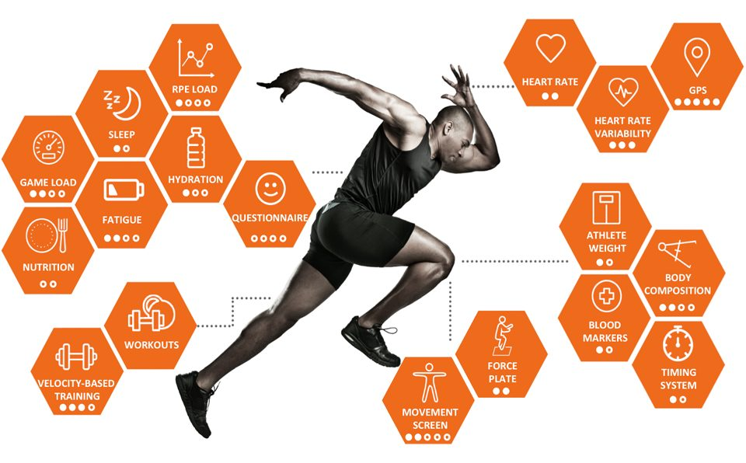

Executive Summary
Sports Science will be extended to monitor, report and research areas across the FTEM framework and to support development across referees, team managers and coaches and all GAA codes. Our provincial referee Sport Science support program will provide a variety of support and feedback. This ranges from Performance Analysis provision observing and recording events and actions during competition and training environments. The content in Sport Performance Analysis examines techniques used to assess and monitor sporting performance using real-time and lapsed-time coding systems which can then provide easily accessible feedback on decision making and learning experiences. This area will also branch out to providing GPS analysis of the physical aspect of officiating games at various levels, regular testing to meet national targets and education on how to train smarter and gain the best possible outcome in the most efficient way. The aim of all of these areas will be to provide information sessions, conduct testing and training workshops, for the pre-season, in-season competition and post-season to generate feedback and an overview analysis.

The Inter-County Performance scene has developed to the point where each county has some form of analysis feedback live in-game and post-game analysis. Our aim is to assist these counties in doing so by providing the best possible program with ease of access and acceptable governance. Our plan is to devise a platform whereby analysts will have the equal amount of quality, multi-angle game footage provided to them by establishing an online provincial hub where these games will be stored, and access permitted to coaches. This requires liaison with key stakeholders ranging from event staff to broadcasting companies and support staff. The outcome resulting in a better provision for our provincial analysts as well as a more accurate analysis for our media reporting personnel delivering live coverage through social media outlets.

With the emergence of many coaches delving into the area of Performance Analysis we aim to facilitate this learning by providing annual workshops at various levels in accordance with the GAA Performance Analysis Accreditation Program (equivalent up to ISPAS Level 4). The Rationale for developing this system is as follows:

- To ensure players receive high quality analysis support empowering their holistic development
- To provide a quality assured register of GAA analysts to coaches and administrators
- To support the development of a community of practice for GAA analysts in line with the GAA ethos

An Introductory Workshop will be aimed at those during the off-season period with an interest in the area or with limited knowledge while Accreditation will focus on a quality assurance framework, educating and providing feedback based upon varying levels of experience.

Sport Science can be a complex area to understand for many. We aim to simplify, without diluting key areas which can be directed at club coaches to take away pieces of information and strategies of which they can easily apply direct into their teams and have a positive effect on their players. At various times of the year, we will aim to provide workshops and practical seminars in relation to what coaches will be able to implement at that time. For example, a pre-season, in-season and pre-championship program of workshops will be devised with information including appropriate fitness testing, development of appropriate speed and fitness, warm-up, cool-down and recovery strategies, as well as Sport Psychology techniques.

Academy Squads within our province require some of the closest monitoring due to intense playing and training schedules. These players, identified as some of the best with their counties, make up part of academy squads which participate in competitions and training sessions at various times of the year. Due to this schedule alongside club, school, other sports and education commitments, the need for a monitoring system for activity and injury has become a priority. This program has become influential in tracking daily wellness, fitness scores and activity levels and provide coaches with feedback if players flag up of becoming high-risk to injury or illness. This, alongside educational workshops for nutrition, hydration and lifestyle, enables coaches and physios to set up an intervention plan to avoid such instances, allowing these academy players the benefit of playing injury free for longer while providing an education process along the way.

Our new KS2 coaching program will be involved in generating up to date and valuable research data on heart rate analysis changes over a period of time showing the differences that this program will have and the potential health benefits to be gained from such a program. The data will be collected on-site from coaches and then processed via the Sport Science Officer to generate reports on how effective the coaching sessions are and how they vary from the various aspects of the PE Curriculum. The sessions will also compare indoor to outdoor sessions due to availability of outdoor facilities in the winter months and show the impact these seasonal changes may have.
With this in mind there could also be some future comparisons to be done alongside GPS measurements with varying distances and speeds.

As we move forward over the next three years, we wish to build capacity in the player pathways. We want to encourage our volunteers to engage, to build their knowledge and competencies in areas that they can support players. We will work with National GAA to ensure that accreditation of individuals working on our system to ensure that they are qualified to work in specified support areas. We will encourage an integrated approach to solving issues and challenges keeping the player at the center of the process.

introduction
- Sports science supports within Ulster is given to players, coaches and referees. Each group has different demands and needs. The current programmes are bespoke and there to suit the needs identified.
- Ulster has been delivering sports science as part of its programme since 2002, introducing technologies, programmes and good practice during a close relationship with the Sports Institute NI.

- In the intervening period, commercial companies and professionals have grown into this space and many county teams now acting independently with their own backroom teams. There is some cross-county collaboration with the online sharing of video footage and communities of practice around sports medicine.

- In the interim some excellent projects have emerged in association with the Sports Institute - the Gaelic groin ( https://ulster.gaa.ie/pals/resources/activate-warm-up/report-of-gaelic-groin-think-tank/) and the activate warm up (https://ulster.gaa.ie/pals/resources/activate-warm-up/)

- Excellent work was completed with GPS and Referees feedback as far back as 2003. This has formed the basis for current work with the referees academy that has been enhanced with the input of referee medical checks and one to one mentoring in performance and lifestyle advice.

2.sport science and player pathway model
- Sports Science is now taken in this context to include the following areas:
Ulster GAA currently supports three main groups: Referees Academy, Player Academies and the Support Services with County Teams. We provide GPS services for gathering and interpreting workloads. We utilize the video technologies for gathering, analysis and sharing games footage. We provide education opportunities for players and referees through the Performance and Lifestyle Programmes. We use the Smartabase systems to gather information for players and coaches. There’s still a number of areas that we need to address with any plan moving forward.
Our vision is to
- “maximize performance, and resources while ensuring long term athletic development of players and officials, using cutting edge sport science, to promote higher levels of performance, amongst our players, officials and coaches while ensuring that the player welfare is kept at the center at all times.”
- Given the limited resource that we operate with at Ulster level this is a challenge. Our vision and plans are aligned with the player pathway and is designed to influence behavior and make changes to club and county players but with an education programme for coaches and volunteers working with teams and within backrooms.

Strength & Conditioning

Performance Analysis

Performance Skills

Performance Skills

Lifestyle Management

Strength & Conditioning

Lifestyle Management

Strength & Conditioning

Performance Skills

Fundamental Movement Skills

Athletic Development

Performance Analysis

Performance Analysis
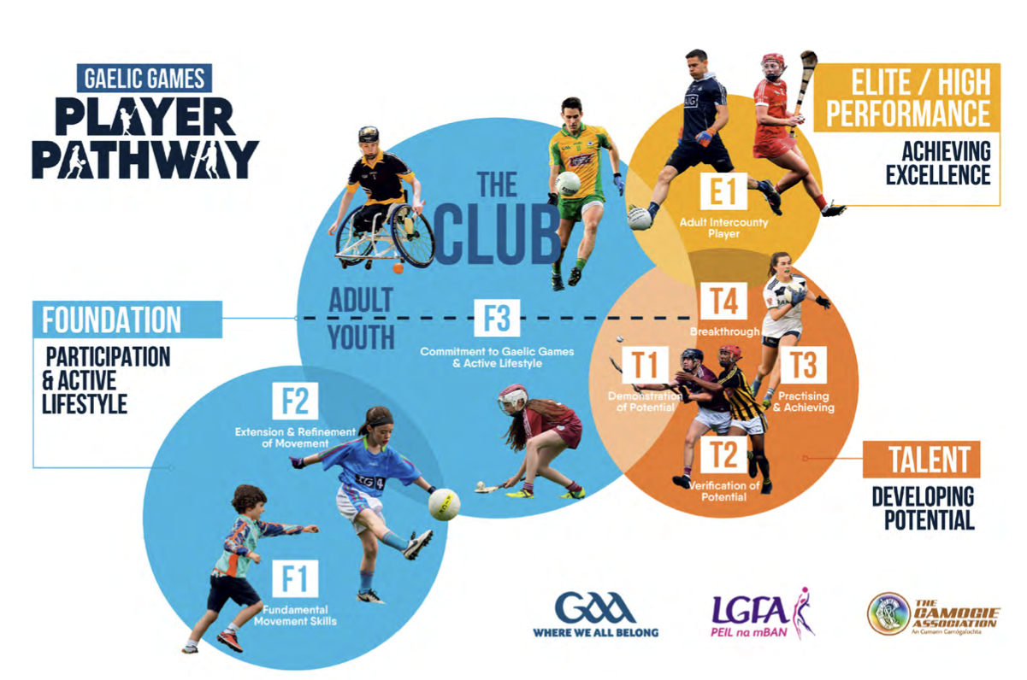

OUTCOMES – sport science
The key drivers for the sports science policy:
- maintain the highest sports science standards to ensure the applied research outcomes are meaningful and change behavior and practice.
- provide a high-level support to all counties covering all scientific disciplines, focusing on improve the performance of the player and the teams.
- embed a framework for athletic development that can be applied across the player pathway model from grassroots coaches to inter-county support teams.

3. Policy to Practice – sport science
To provide a guideline to our members the following broad principles should be applied:
- F1, F2, F3 - Club Player Development
  - Players…. From an early age, (F1) rudimentary and fundamental movement skills should be delivered through clubs and early years in primary schools. Embedding the basic sports specific skills (F3) is also a role in schools and clubs through a games-based approach. These are then taken further in clubs in the next phase with our youth (F3). Research supports the use of small sided games and its use in developing fitness.
  - Coaches are encouraged to become familiar with basic sports science applications. The use of basic fitness testing and performance analysis techniques are built into modules on the accredited programmes. Personal development opportunities are presented through accredited courses and mentoring opportunities.

- T1, T2, T3, T4 - Player Academies.
  - Players and coaches working with county academy squads, should maximize the service provided and add value to the player experience: maximizing the opportunity to recruit as many players as possible at T1 using not only gut feeling but some selectins tools: giving players an opportunity to excel at T2 and reviewing their coachability and attitude: developing a focus on Performance and Lifestyle; Video Analysis and Athletic development sessions to monitor their reactions to development in T3 and T4. Mentoring coaches (volunteers) in specialist areas through performance workshops is central to this strategy.

- E1 - Elite Inter-county players
  - With the Senior Inter-county environment, the focus moves to E1. Players are in the system and performance and lifestyle, load monitoring; strength and conditioning, video analysis and phycological preparation become the focus.

- Referees Academies
  - The officials required performance and lifestyle mentoring, video analysis and goal setting and athletic development sessions maximizing the use of GPS Technology, video technologies and the use of one-to-one mentoring.

- Service providers
  - Need for performance and High-Performance solutions and opportunities to learn and share. Service Providers require exposure to high-performance workshop environments and are challenged to share good practice, develop communities of practice and engage in mentoring programmes as well as building capacity in their system through Internships.

4. What does it look like?

Sports psychology - PERFORMANCE SKILLS (t3-t4, F3 (Adult) E)
The delivery of sport psychology is a specalist area but coaches are exposed to it at level 2 and should be able to apply some basic techniques and tools with their players. This will be faciliated through
- Practical applied education workshop opportutnies for club coaches.
- Sports Psycholgy support to inter-county teams - Match preparation and recovery
- Communities of practice and conferences with key stakeholders

Performance analysis, statistics, technology (t3-t4, F3 (Adult) E)
The area of statistical and video information feedback is becoming an ever popular and valuable tool. We aim to provide and educate on reliable and advanced methods including the use of latest technology and methods of feedback which can have a positive impact upon individual and team performance. This will be facilitated through:
- Quality Assurance Accreditation Program for Analysts
- Academy & Senior level support
- Research projects to show statistics and trends
- Coach/referee academy feedback report and support
- Managing a provincial training load management system for academy players
- Creation of a new load management system app based on the needs of Senior level athletes

athletic development (f2, f3 (Youth) t1-t2)
Athletic development from an early age provides the building blocks for future successes.
It is built on good functional movement embedded in the early years. Juveniles need to be exposed to good coaching and build technique and competence around basic body movements.
This work can be done in schools and clubs and needs to be embedded before the player gets into F3 and Talent spaces.
We are challenged to have our players arrive into the talent phase with good athletic movement.
As such the content of the athletic development programme is closely related to the player pathway. This will be facilitated through:
- the application of best practice within the player pathway model and the use of athletic model indicators in player selection - Peak Height Velocity (PHV), VO2Max
- building the Knowledge and Competency of club coaches in the early years of athletic development.
- developing an understanding of the growth of a young person and where the effects of certain types of training can be maximized for the purpose of achieving maximal athletic potential.
- developing an understanding of late specialization model for boys and girls based on stages of growth.

strength and conditioning (f3 (Adult) t3-t4, E)
Strength and conditioning professional are very much part of the GAA coaching community. GAA Coach’s often underestimate their own coaching ability in this area. It is an important part of player preparation and the pathway. Delivering the right content and coaching the right technique is essential. Senior county teams and clubs now employ an S&C Coach to work within their player pathways. The biggest challenge we have is to co-ordinate development across club, school and county. This will be facilitated through:
- Development of strength and conditioning resources for stakeholders to address the levels F1 - E1 within the player pathway
- Practical workshop with coaches to enhance their competence and knowledge on skills, techniques and movements based on athletic ability.
- Communities of practice through workshops and seminars shared with stakeholders within counties: schools: clubs and county academies
- Projects into how Strength & Conditioning can/are having an impact -Measurement

PLAYER and performance monitioring (f3 (Adult) t3-t4, E)
Athlete and Performance monitoring (with feedback) is what coaching is about. Having information to assist with decision-making can inform and enhance the coach’s decision-making. The monitoring, collection and analysis of the information is central to this process. For the county team collecting information during games can involve backroom staff along with injured players. During training this can be the S&C Coach or sports scientist. At club level resources are less and expertise not as available. It is important that whatever the competitive level, that information gathered is relevant and can optimize preparation, minimize injury risk, improve communication and maximize performance and availability. This can be facilitated through:
- Monitoring daily wellness and training load – Acute: Chronic load ratio
- Tracking injuries and illness and sleep quality
- Managing of test results and measuring individual and group progression
- Utilizing applications such as Smartabase, Metrifit, ActiMet
- The Provision of workshops to educate providers of wearables and technology
- The provision of workshops and mentoring to educate coaches using the results.
- Coach/player accessible online resources with video & audio demonstrations

sports nutrition (f3 (Adult) t3-t4, E)
Fueling the body to perform is central to any athlete’s performance at training and competition. Given the nature of our sports, players can turn up to training after a day’s work or schools activity and they are not ready to engage in physical activity. For many young athletes it’s their parents who prepare their food. Education for parents, players and coaches is an essential element of this area. This can be facilitated through:
- Weight and hydration monitoring of players
- Parents workshops on food preparation
- Player workshops on food and alcohol intakes
- Player workshops on preparing drinks
- Coach/player accessible online resources with video & audio demonstrations
- Tools and techniques implemented by coaching staff

performance and lifestyle (f3 (Adult) t3-t4, E)
Performance and Lifestlye (PALS) is something that engages a number of areas. Performance Skills and the pillars that underpin success as well as the lifestyle and preparation for competition all contributing to the overall performance.
Although the focus will be on youth and adult. Good practice can be embedded at a younger age. Good habits can be established with children brining their own water bottle to a session and having a snack in their bag for post training.
With all our players there is an important balance to be achieved between work, training, games and an individual’ social life.
For the club player there should be less pressure, but this is totally dependent on the attitude of the coach. Club players are not preparing for inter-county competition and where they are this can lead to drop off by many players.
For the players on the performance and high-performance pathway they decide that they want to go this way and have the potential to achieve. They are prepared to put more time and effort into their preparation, their training and competition commitments. However, there is still an important balance to be achieved and players and coaches need to pay attention to lifestyle issues that can affect performance. This can be facilitated through:
- Education workshops on nutrition, hydrations and sleep - target audience referees, coaches, players and parents.
- The use of practical tools that can embed good practice across this area.
- Engagement with schools and club environments to increase awareness.
- Coach/player accessible online resources with video & audio demonstrations.
- Implementation of warmup (activate) and increase awareness of recovery tools.

recovery methods (f3 (Youth & Adult) t1-t4, E)
Recovery between session and games is essential to replenish the body. There is more than one way to facilitate recovery.
For the county player this may well be formalized with their backroom teams. For the club player it is usually left very much up themselves. In either situation, climbing into a vehicle and travelling home from a game can cause the body to seize up.
A number of recovery methods are recognized and it’s probably best to give the individual the opportunity to work up their points through their preferred method. https://ulster.gaa.ie/pals/resources/match-preparation-recovery/.
This can be facilitated through:
- Increasing the player/ coach knowledge of muscle reactions to physical activity.
- Provision of workshop for player / coach to illustrate the different types of recover.
- Practical demonstrations through workshops of less used methods.
- Coach/player accessible online resources with video & audio demonstrations
- A score card for players and coaches to measure and optimize their recovery performance
- Showing benchmarks of sleep performance for optimal recovery and regeneration

INTEGRATED APPROACH TO SERVICE PROVISION
Service provisions do not operate in isolation. An integrated approach to working with players is essential as each will have different needs. In the same way delivery of key elements in isolation from a coach or a parent can lead to the poor implementation of the support.
The challenge is to see what the issues are with the player and bring a joint solution to the issue or challenge. In the same way, we deliver pitch sessions and the integration of some athletic development or conditioning can be implemented into the session. This approach to solving the problem with service providers around the table is key in high performance sport.
Within the player pathway, there is also a need for basic information around the key areas. This starts to prepare players by drip feeding in what to drink, what to eat, how to recover. It starts to introduce simple mental skills training and it starts to develop the training age earlier in the whole area of athletic development and strength and conditioning.
Self-reflection through the use of video analysis, helps players to be analytical and to reflect on their performance and the execution of skills under pressure and the decisions they make on and off the ball. Such reflection also helps them to assess their level of fitness, their speed, strength and their endurance. Their ability to integrate their lifestyle decisions, nutrition and hydration inputs, to the performance on the pitch become real.

Conclusion
This document is designed to give us a holding position on where we are and what our ambitions would be. We have been striving to get each county self-sustainable in the key service areas. This is possible at senior county level where each team (for the most part) are well supported by physiotherapists, strength and conditioning coaches, medical personnel, performance analysts, nutritionists, psychologists and coaches.
Over the years these people at senior county level came in with a specific manager and then moved on in most cases with that manager. In some counties the doctors and physiotherapists remained the same. But other personnel changed. Performance Analysis and Strength and Conditioning were once the jobs of volunteer coaches on the backroom team. These like coaches have all morphed into professional jobs in the backroom team.
Accreditation of these individuals in these key backroom team roles has now emerged as a priority at National GAA. These processes are set up to assure quality provision at county level. What is missing is the filter down of such a service to the player pathway from T1-T4. There are opportutnies here to build capacity within the counties by developing these communities for practice around key disciplines, to allow for the broader implementation of support areas. Some areas are professional and cannot be replaced but a certain level of support on other areas could be facilitated.

