TALENT MANAGEMENT AND HIGH PERFORMANCE

POLICY AND PLAN
2021-2024

Foreword

The GAA is an indigenous sport played across the island of Ireland. There are however a growing number of overseas units across the world. Players represent their club, their county, their Province and on occasions their Country. This document focuses on the talent development and progression of players through the player pathway to the senior inter-county teams which represent the high-performance end of our sports.

Over the last twenty years our systems have developed substantially and with the emergence of County GAA Centers in each county, there is the facility and the staff to support the development of performance and high performance in a more formal manner. Some counties have state of the art facilities and others are still emerging. However, there is the desire to put in place an environment and support system to nurture our top athletes.

There is concern within the GAA at the training and competition loads that young talent players are exposed to. GAA has taken some steps to address this, by adjusting the age grades and decluttering the performance pathway for developing talent into senior competitions. This has been welcomed. One of the biggest challenges however is develop better coordination and development programmes across the stakeholders (schools, clubs and counties) and to establish windows where the players can focus on competitions and training with either the club, schools or county.

There is a similar concern with high performing players in our senor squads. The challenge remains on how to address conflicts with training and competitive fixtures across clubs, higher education and county.

As school, club and county coaches, service providers, and school, club, county and provincial administrators we need to remember that the health and wellness and the player’s welfare has to be central to all decisions we make. Co-operation and communication between stakeholders in this environment are central to our future and well-being of our greatest asset our players.

Oliver Galligan John Connolly
President Ulster GAA Chair Ulster Coaching and Games

Content
foreword 3
- Introduction
- Talent Management in the Player Pathway
- Policy to Practice
- Moving Forward
- What does it Look like in Practice?
  - Family, School, Club, County engagement
  - Identification, Selection and Induction
  - Management and Retention
  - Deselection and Debriefing
  - Player Progression and Education in the Pathway
  - Transition to Elite teams

- High Performance and Elite Player Management
  - Player centred and High Performance Players
  - Coach / Service Provide Education in the Player Pathway
  - High Performance Player Educaiton
- Conclusion

executive Summary
- Talent ID and management are integral parts of the FTEM framework. This needs constant reflection and adjustment to ensure recruitment procedures, the performance environment and exit strategies are fair and consistent across all counties and codes.

- It is essential that selection procedures are clear, consistent and agreed across clubs, schools, academies and codes.

- A high-performance environment that nurtures talent and focused on developing the person as well as the player is critical not only for the players but for the well-being of communities.

- Where players are being deselected form an Academy there must be an agreed exit strategy in place which clarifies the areas for development and a potential route back into the squad.

- The clubs must always be kept in the loop in relation to their player’s performance, injuries and in particular where clubs can support academy players.

- The schools must also be keep informed of progress, injuries, areas for development and player load.

- The County Boards must support the academies through an agreed programme of fixtures, facilities and resources as necessary.

- The players parents need to be clear on the academy philosophy, the educational inputs as well as areas where they can impact on their child’s progress.

- Player transition need careful management and critical junctions identified and support put in place to help players make the next step.

1. Introduction
- Ulster GAA are committed to delivering a talent management and high performance programme that delivers better players as well as people into our systems and communities It is our aim to have clearly defined systems in place that deliver for the families, players, clubs, schools and counties.

- The FTEM framework has recently been adopted by the GAA, Camogie ad LGFA as a model that reflects the journey of the player (Talent Academy and Player Development Review Committee Report 2019)

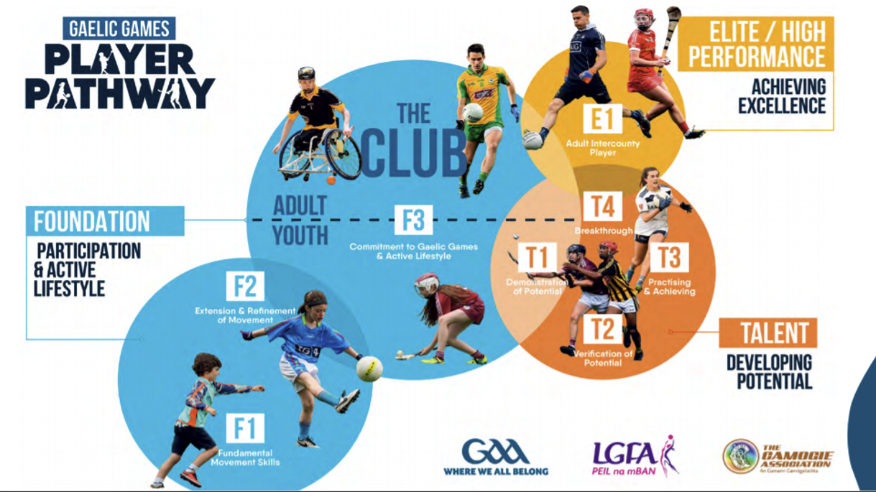

- Ulster GAA in association with the Sports Institute NI, has developed the Performance and Lifestyle Support Resource (PALS), to support the education of players and coaches and provide practical tools to players (https://ulster.gaa.ie/pals/ )

- The identification and recruitment of talented young players remains a challenge. It is evident and recognized that young players develop at different rates and often the younger players or those born late in the year can be omitted from the system (Relative Age Effect - https://playerdevelopmentproject.com/relative-age-effect/)

- It is also recognized that when young players are in the system, the coach has limited time with them either in the school, club or county environment. Experience shows that the time available is spent on coaching and more recently on conditioning.

- In a similar manner experience shows that coaches within these environments are often competing for the players, where there is overlap in competitions or training programmes. In this scenario the welfare of the player needs to be front and central to any decisions by coaches, teachers, service providers and fixture makers.

- However, with buy in from all stakeholders – clubs, schools, academies, service providers, parents and players – a successfully aligned Talent ID and High Performance programme is entirely achievable.

- The environment for the talented young player is complex and it needs to be managed and understood by all stakeholders involved.

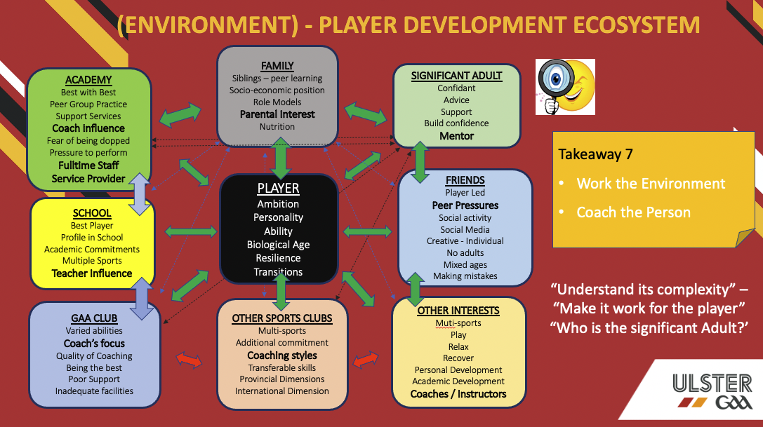

- The transitions into Academies, is a critical junction for talented young players. Players may be exceptional among their club peers, but they are now in a different environment where they are competing with other exceptional talent.

- Players will also transition out of Academies either back into the Clubs or into U20 and Senior County squads. This again is a critical junction that needs to be managed.

2. Talent management in the player pathway Player Centered Development PATHWAYS
- The report on Talent Academies and Player Development (2019) has put the player front and center to programme development, fixtures and player development decisions.

- It recognizes the need for Academies but emphasis that they must not merely replicate what is already happening in the schools and clubs in the development of talent.
- When we look at the FTEM model for player development, this policy looks at T1-T4 AND E1. Within this context the document presents best practice and guidelines for all stakeholders.
- The what and where things should be delivered is the challenge moving forward. This will ensure that there is coordination, communicaiton and cooperation on content and practices around the development of talent young players. It is noted in the report that “Squads add value to player development” p5
- The report also suggests the need to mirror the player pathway framework with an educational framework so that “all stakeholders can develop a clear understanding of how to support individualized development” (p9)

- High Performance inter-county teams are more difficult to engage, given that there is a reluctance to share, However, we have been able to make inroads around anti-doping, concussion awareness and performance analysis and video sharing platforms. There is still much work to be done in sharing of best practice around conditioning, medical support and injury management.

3. Policy to practice
Policies and procedures are key to engaging all stakeholders and ensuring buy in and adherence to agreed protocols and good practice. If our policy is to keep the player at the Centre of the pathway then our Academies and our Senior County teams should adopt the guidelines for good practice as outlined here.

sTAKEHOLDER Coordination and Cooperation
- Stakeholders in the Academy programmes include the schools, clubs, county, parents and guardians, teachers, coaches, service providers and players.
- Player pathway managers need to nurture and to manage these relationships and to fire fight where required, but ultimately to embed a smooth continuous development pathway for players in these environments.
- Teachers, Club and County Coaches and service providers need to communicate and cooperate and provide a joined up programme that bespoke to the player. This avoids the conflict and the stress and strains that we see too often with our young players who are forced to make choices set out by adults.

Resources for the player pathway / PLAYER DEVELOPMENT
- To ensure that programmes are complimentary between schools, county and club, the player pathway managers are required to co-ordinate meetings between schools and county and club. Curriculum or content for the programmes needs to be discussed and agreed and who is delivering that part of the programme. The challenge is to engage in schools and clubs and offer some of the programme to the wider playing population.

Resources for HIGH PERFORMANCE player development
- Commitment must come from the coaches and service providers working with county teams to engage and share best practice. A rising tide can lift all boats! To enhance best practice and co-operation an Ulster GAA Performance Coach should be in place to help develop communities of practice around key areas such as sports medicine, strength and conditioning, performance analysis, coaching and sports psychology. The Provincial Performance Coach should work closely with the County Player Pathway Manager and engage post primary schools.

4. MOVING FORWARD
Policies and procedures are key to engaging all stakeholders and ensuring buy in and adherence to agreed protocols and good practice. To achieve this there needs to be two key appointments in Ulster
- Performance Manager - to manage the service providers and develop communities of practice across different disciplines within our high performance teams
- County Player Pathway managers - to manage the player programmes across different stakeholders

5. What does it look like in practice
The Player pathway manager is central to coordinating all stakeholders and ensuring best practice delivery and adherence to procedures and practices agreed. Keeping the player at the Centre of the programme the counties are challenged with embedding good guidelines and protocols around the following areas.
  - Family and Schools engagement
  - Identification, selection and induction
  - Management and Retention
  - Deselection and debriefing
  - Player progression and education in the pathway (PALS)
  - Player Transition to Elite teams - from F3 (Youth) to T1-T4 to E1
  - High Performance Players
  - High Performance Environments

FAMILY, CLUB, SCHOOLS ENGAGEMENT AROUND ACADEMIES
The success of academies is dependent on the relationship between the parents, clubs, schools and the academy system. With proper consultation and involvement of all these groups ownership of the programme can be shared among all the relevant stakeholders. All must feel that they have a vested interest in the success of the academies and that they have an active role in their success. All involved need to be clear on the philosophy behind the Academy concept, the mechanics of the programme and what their specific role involves.
In addition we need to explore the parameters for selection and establish a range of critieria that can be adopted by counties to support more accurate talent identification. Brining talent into a system places a huge onus on the county to ensure that the individual gets an experience that is worthy of the status of Academy. In addition there is a player welfare issue that needs to be addressed and revisited frequently. Counties need to establish what they are after in terms of player recruitment
What type of player do we want?
Players who have the potential to be: highly skilled in all aspects of GAA performance, on field leaders and possess decision making qualities; self-reliant and responsible; high personal values (strong work ethic, high self-esteem and self-motivated); well-balanced in terms of GAA; with vocational and social development central to the process; resilient in crisis situations demonstrating leadership under pressure

T1- TALENT IDENTIFICATION, SELECTION / deselection OF ACADEMY PLAYERS
The criteria for Talent Identification to County Academies must be agreed Nationally and by all stakeholders. While taking into account the technical, tactical and physical attributes equal consideration must be given to the psychological and social aspects. The entire process must be as much about creating better people as well as footballers/hurlers. These principles must be the same for club, schools and academies so that everyone is on the same page. Exiting the high-performance pathway should not come as a surprise to an Academy player as coaches must continually communicate and listen to their players! (Appendix 1 - Phases of Talent)

T2- Management and retention OF ACADEMY PLAYERS
When a player is selected to an Academy both parties must be aware of their commitments to the programme. From the player’s perspective they need to know the commitment required in terms of time, expectations and any work required outside contact time. The academy is charged with delivering a programme of coaching, educational inputs, parental contact, feedback on progress, individual programmes for improvement and service provision where necessary.

T2- DESELCETION and debriefing OF ACADEMY PLAYERS
All academy players should have at least one appraisal meeting per season. This is an opportunity for both the players and coaches to feedback on their progress against specific criteria. Where a player hasn’t met the agreed levels of performance it may be deemed prudent to release the player from the academy. In this case areas for improvement must be clearly communicated to the player, parent, club and school. It must be made clear that players will continue to be monitored and where improvement has taken place, he/she can be readmitted to the academy. (Appendix 2)

T2 - T3 - T4 - PLAYER PROGRESSION and education in the pathway
We are aware that we are preparing these young boys/girls not just for a life in sport but for life in general (better players and better citizens). So, as part of the Academy programme players will be exposed to various educational inputs from service providers. These can involve nutritional, hydrational, recovery, mindfulness, citizenship inputs……

T4 - player transition to elite teams
The expectation is that the academy system will produce a larger pool of players with the necessary attributes to compete at senior county level. Players will move through the various academies and some will eventually progress to senior county. Others will return to their clubs as better players and more rounded individuals. These players can be selected at a later stage based on their club performance.

COACH / service provider EDUCATION AND THE PLAYER PATHWAY
- Given the nature of engagement with young players in a performance pathway, there are specific requirements that a teacher, coach or service provider needs to know. Coach and service provider education opportutnies should address the needs of the player in this environment.
- Commuities of practice organised at county level, that engage club coaches, teachers and county coaches should be organised on a regular basis. At these gatherings issues and challenges can be addressed, common curriculum addressed and coordination and cooperatin of player development achieved.

6. High Performance and elite player management
- Players emerging from the player pathway into the elite player systems require continued support. Young players in particular who have multiple commitments across higher education, club and county are particularily vulnerable, as many will have moved away from home for the first time and living in student accommodation.
- Coaches and managers need to keep the needs of the player at the centre of their decision making and are challenged to addresses the issue of multiple teams and accommodate young players who are into higher education and experienceing competition in this environment
- To be the best there is a constant need for education and educational opportutnies. The Senior Team Performance Coach can complete a needs analysis across service providers, coaches and medical personnel.
- Within this environment commuities of practice will be set up within different disciplines and across disciplines. It is envisaged that we seek external support and expertise to bring in new ideas and challenge our existing ideas and practices all to enahce the player experience.
- The High Performance engagement with U20 and Senior County is difficult to gel collectively and individual gap analysis based on needs is required to give bespoke support to the HP environment.

PLAYER CENTRED - ELITE PLAYER MANAGEMENT
- E1 - When a player is selected for his Senior county team they will require a network of support. Very often these players will spend a number of seasons with limited game time. This is the crucial period of their development when they need support in terms of positive reassurance and some clear messages from the management and a clear personal development plan to reatin their motivation and direction.
- M - Mastery refers to the player who is a seasoned campaigner in the Senior County squad. They become a role model and a mentor and perhaps part of a senior leadership group within the squad. This group of players have the experience and the skillset to help fledging players up the high-performance ladder. They can be deployed as mentors to academy squads and as buddies for emerging players coming into senior squads

COACH / service provider EDUCATION IN THE PLAYER PATHWAY
- Given the nature of engagement with players in a performance pathway, there are specific requirements that a coach or service provider needs to know. Coach and service provider education opportutnies should address the needs of the player in this environment. Is there a link here to relevant information
- Commuities of practice organised at county level, that engage club coaches, teachers and county coaches should be organised on a regular basis. At these gatherings issues and challenges can be addressed, common curriculum addressed and coordination and cooperation of player development achieved.

HIGH PERFORMANCE PLAYER EDUCATION IN THE PLAYER PATHWAY
- If the pathway system is joined up, the various stages should compliment and feed off one another. Player should arrive at a senior county set up with a training age of 3+ in most areas. Some exposure to lifestyle and performance skills, strength and conditioning, recovery and psychological skills will make the transisiton into a senior environment easier. Other issues become important with anti-doping, recorvery methods, self reflection and use of data to inform performance. Education in the E space is enhanced but it should be a natural progression from what players were exposed to in the T1-T4 space.

6. Conclusion
- The FTEM player pathway was recommended by the National GAA Report on Academies and Player Development (2019) and it made some key recommendatins around the management of talented players through our pathways keeping the person at the centre of the process.

- The pathway framework requires a number of key people to support the delivery of this vision: a Player Pathway Coach: Teachers in the systems: Performance nd Lifestyle Coach (Sports Science, Strength and Conditioning, Education).

- To keep the player at the centre and to ensure that all players get an equal oppotutnity, programmes in schools, clubs and counties need to compliment and support one another. There needs to be cooperation, communicaiton and cohesion between the different parts of programmes. An agreed curriculum that can be delivered effiecently and effectively across all stakeholder environments will support player development and reduce training loads and education elements.

- To ensure a joined up approach, there neeeds to be engagement on a regular basis through communites of practice, and where stakeholders are not engaging they need to be called out. Personal intersts and agendas have no place in the environment that we hope to create, where we will allow our young players to mature and achieve their potential.

Appendix 1

Talent Terminology
The phrases ‘talent detection’, ‘talent identification’, ‘talent selection’, ‘talent development’, and ‘talent confirmation’ are loosely used throughout all levels of the performance pathway. In particular, the terms ‘identification’ and ‘detection’ have largely been used interchangeably to describe the recruitment of gifted people into sport, as well as the identification of gifted and talented people already within a sport.

The Phases of Talent
To identify and develop World Class Talent requires a structured sport specific pathway unique to the sport that encompasses four key phases of intervention:
Phase 1: Planning and preparation
- Talent Strategy – vision, key performance indicators (KPI’s) and investment
- Intelligence Gathering – world trends, performance gaps, target events, disciplines, and genders
- Talent Conversion – progression up the pathway/barriers
- Management and Personnel – how and where does the programme operate, staff structure, resources, recruitment, and CPD
- Support Services
- Innovation and Creativity
Phase 2: Profiling and Recruitment
- Talent Profile – how is this developed, art v science, does it consider future potential?
- Recruitment of Talent – where, known performers, transfer and ID programmes
- Assessment Criteria- athlete history, competition results, progression, skills, and physical and psychological traits
- Recruitment Cycles
- Geographical Search
- Assessment Days
Phase 3: Talent Confirmation
- Planned Confirmation Programme – purpose, duration, personnel, techniques used, and expected standard
- Athlete Responsiveness – expected progression profile
- Exit Strategy
Phase 4: Talent Development
- Coaching – CPD and engagement with High Performance Coaches
- Development Programme – High Performance attributes defined, performance foundation and clear expectations
- Induction – duration, content, insights, and confirm expectations
- Talent Training – expected training hours, volumes, intensities, contact time, monitoring, and training camps
- Competition Strategy – expectations, number of exposures, reward system, and assisting transition to senior
- Progression Profiles – mapping individuals, selection/deselection, and benchmarking
- Support

Appendix 2
ACADEMY PLAYER RELEASE LETTER

Dear *********,
Following a recent review of our players we have re-selected the ****** squad. On this occasion you have not been successful in retaining a place in the squad.
I would like to stress that this does not close the door with your engagement with the development squads. The selection process is ongoing and he door is always open to being brought back into the squads.
We will continue to monitor your progress in club and school matches. We will also review continual feedback from your coaches, the county staff and the other networks that are present at our games.
All players at youth level develop in different ways and at different rates. The potential for reselection is high either immediately or in the future.
To assist you in your journey the coaches have feedback to say that the following areas are where they would like to see personal development in the next phase.
1.
2.
3.
It is hoped that you can focus on these areas for personal development and that we will engage with you again in the future. Many thanks for your effort and commitment during your time with the squad. The County coaches look forward to monitoring your progress in the coming months. Please feel free to give me a call for a conversation and any advice.
Regards,
*********** (County Development Squad Head Coach)

